## 



MongoDB Deployment

20.06.2018

**─**

Sajiv Francis

New York, NY

# TABLE OF CONTENTS:

**TABLE OF CONTENTS:** **1**

**MONGODB ENVIRONMENTS:** **3**

Sandbox Environments: 3

Deployment Environments: 3

QA/Test Environments: 3

Production Environments: 3

**SERVER INSTALLATION AND SETUP (CLOUD & ON-PREMISE):** **4**

Installation on AWS: 4

SSH Into an AWS Instance: 7

Installation of Ubuntu (MAAS) on Premise: Metal as a service 9

Steps for MAAS Installation: 10

**MONGODB:** **13**

ABOUT MONGODB: 13

ADVANTAGES OF MONGODB: 14

What are the uses of MongoDB? 14

What environment needs MongoDB? 14

INSTALLATION OF MONGODB ON LINUX (Ubuntu): 15

Server steps from commandline: 15

START & REMOVE MONGODB SERVICE ON UBUNTU: 17

Step 1: Check if the service is running: 17

Step 2: Status of Mongo instance 17

Step 3: Stop the Mongodb service or Uninstall mongodb on ubuntu 17

MONGODB CONFIGURATION: 18

About mongod.conf: 18

Path to mongo configuration file: 18

Move your data directories into your home file system: 18

Default Mongo database location: 18

Stop the Mongo database: 19

Append the mongod.conf file to change your dbPath location: 19

Copy mongodb data files to your home directory: 20

Rename the original mongodb repository to a new location: 21

**Issues faced:** 21

REPLICATION CLUSTERS: 22

What is Replication? 22

How does replication help? 22

Why do we do replication of nodes in mongodb? 22

How Replication Works in MongoDB? 22

REPLICATION CONFIGURATION: 23

Steps to configure our standalone instance into a Replica Set: 24

**Issues Faced:** 26

Adjust priority for the Replication Set: 28

SHARDING: 30

What is Sharding? 30

Why do we utilize sharding in MongoDB? 30

How does Sharding help? 30

Difference between Replication and Sharding? 31

Sharded Cluster: 31

Shard Architecture: 32

Sharding Strategies: 33

Two types of Shard strategies available in Mongo: 33

SHARDING CONFIGURATION: 34

# 

# 

# 

# 

# 

## 

## 

# MONGODB ENVIRONMENTS:

## **Sandbox Environments:**

* **Developers can add new product features, conduct alpha testing, demo server/ pre-production validation - Check/Test Config’s.**

## **Deployment Environments:**

* **Desktop PC (Virtual Machines to run server operating systems as nodes)**
* **Single Node running on your PC ( Windows, Linux, Unix)**
* **Cloud deployment (AWS, Azure, Oracle Cloud etc.)**
* **Standalone on premise servers.**
* **MongoDB runs as an application/service on your node/server.**

## **QA/Test Environments:**

**- Complex Architectures require similar configuration, data and functionalities of a production server, this is to ensure test results are accurate and don’t affect any processes when changes are transported into production servers.**

**- Test the Architecture**

**- Test the software**

**These QA/TEST servers can be spun up/down depending on cost saving requirements. They provide data surety for production deployments.**

## **Production Environments:**

**- Fault-Tolerant**

**- Auto-scaling**

**- Reliability**

**- Availability**

**Deployment strategies require cross team coordination.**

# SERVER INSTALLATION AND SETUP (CLOUD & ON-PREMISE):

## **Installation on AWS:**

**Step 1:** Log in to AWS Management Console



**Step 2:** Click on launch a new instance

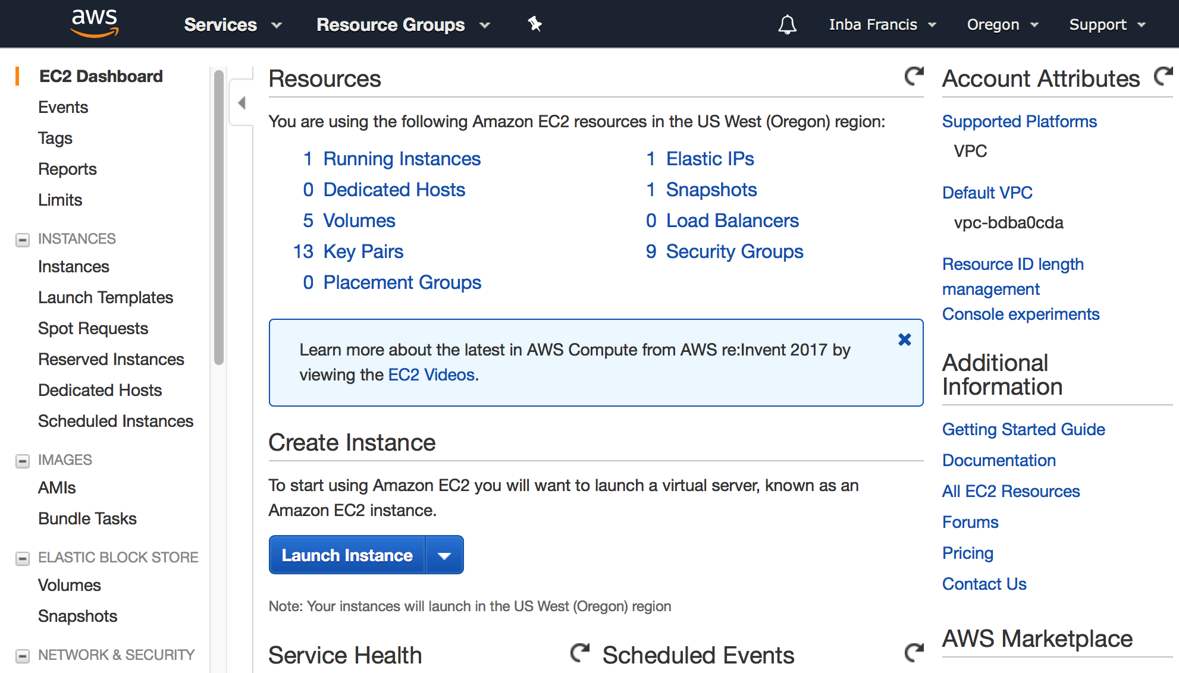

**Step 3:** Select an appropriate server image - AMI ( e.g. Ubuntu, CentOS, RHEL, Windows)

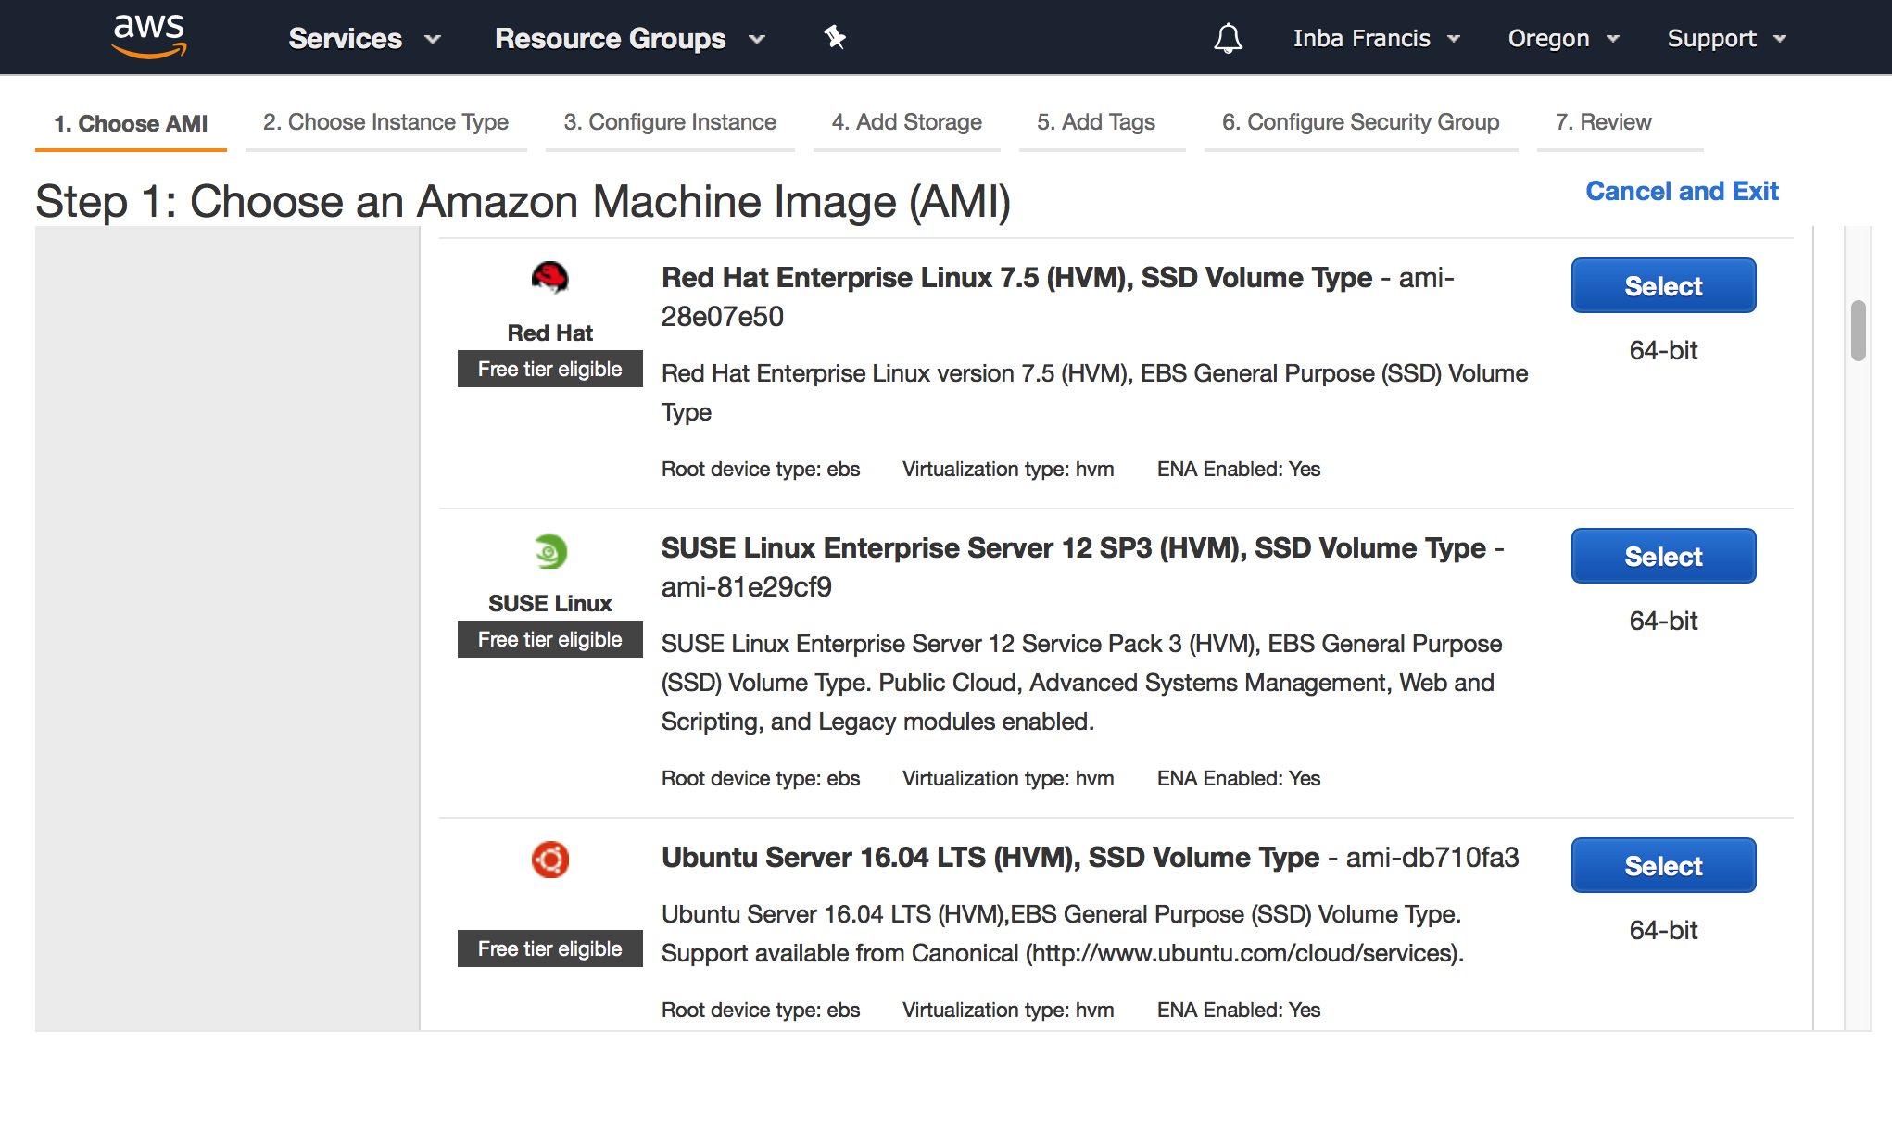

**Step 4:** Choose an Instance type

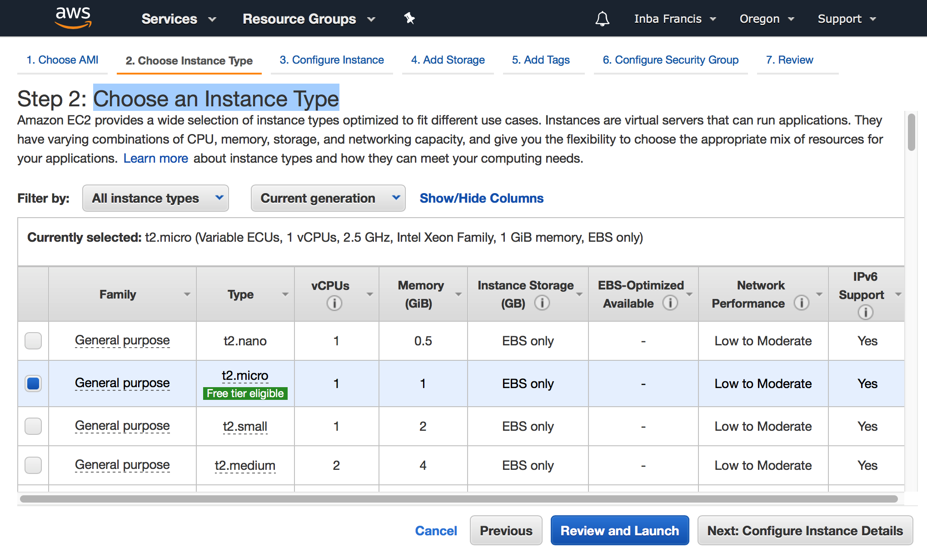

**(e.g. Instance types - t2, m5d, m4, c5d ,c5 ,c4 ,g3 ,p2, r3 ,upto i3 etc).**

**(Storage Optimized, Memory Optimized, GPU - compute/instances/graphics ,FPGA Instances, Compute Optimized and General purpose server instances are available at AWS)**

**Step 5:** Configure Instance



**Step 6:** Add storage

Edit Storage parameters and add storage necessary for your instance.

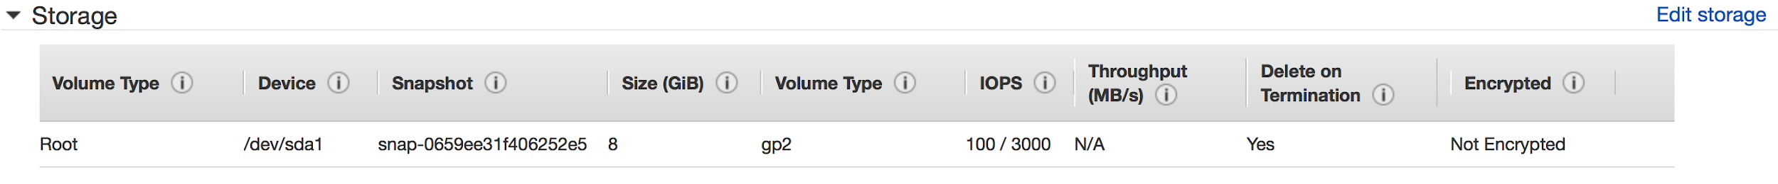

**Step 7:** Add Tags

A tag is a label that you assign to an AWS resource. Each tag consists of a key and an optional value, both of which you define.

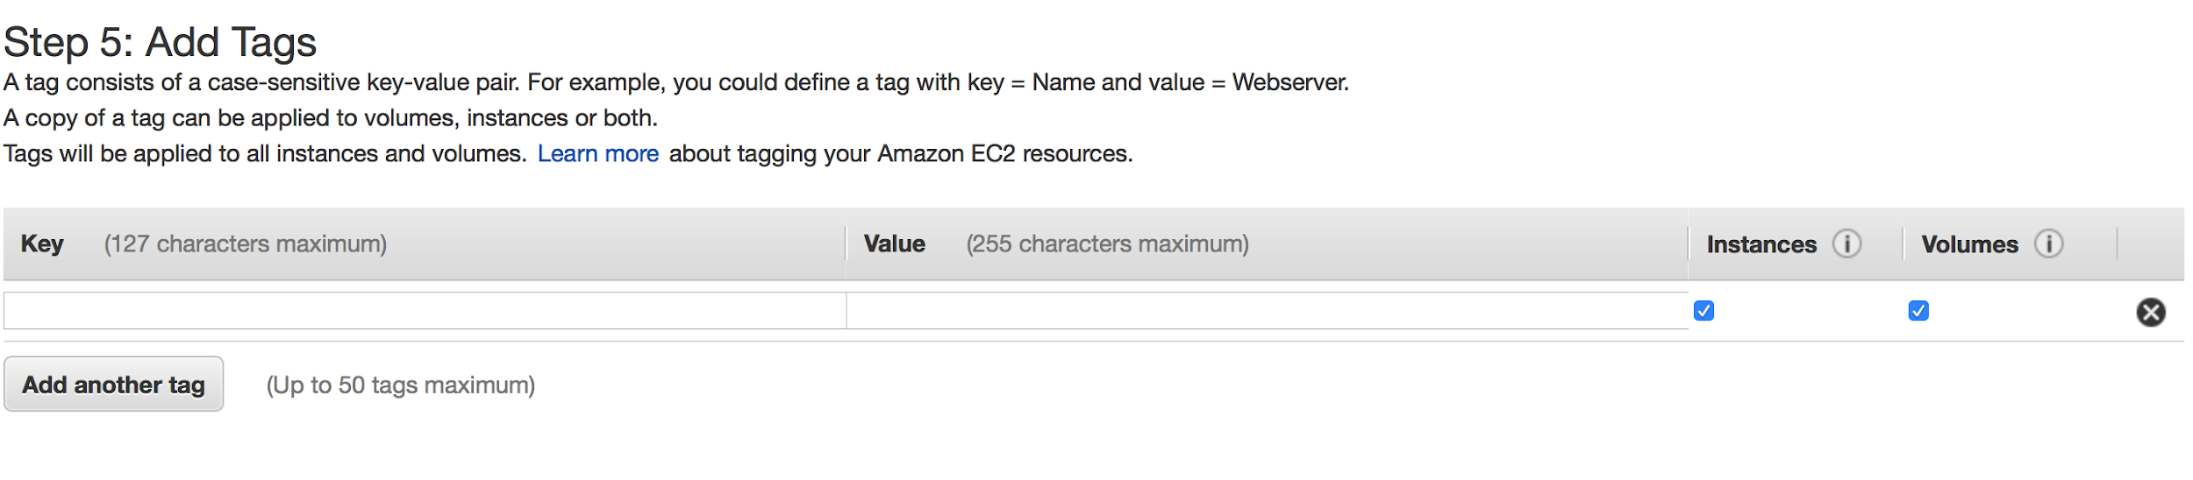

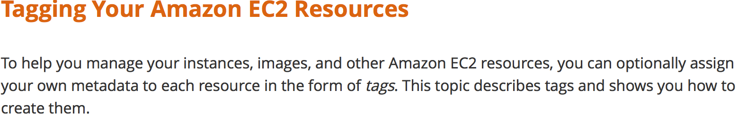

**Step 8:** Configure Security Group

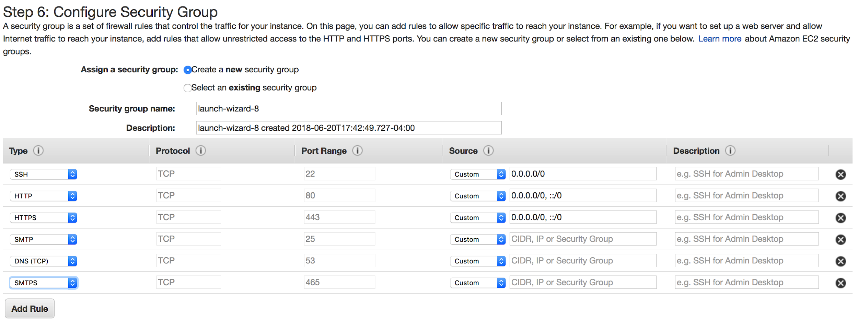

**Step 9:** Review

Once all the requirements for your instance have been configured, select review and launch.



## **SSH Into an AWS Instance:**

**Required:** When you set up an instance on AWS, you would know the **IP Address** and the **root user of your instance**, record and keep this info to SSH into your server.

**Step 1:** Under Network & Security, Select Key Pair

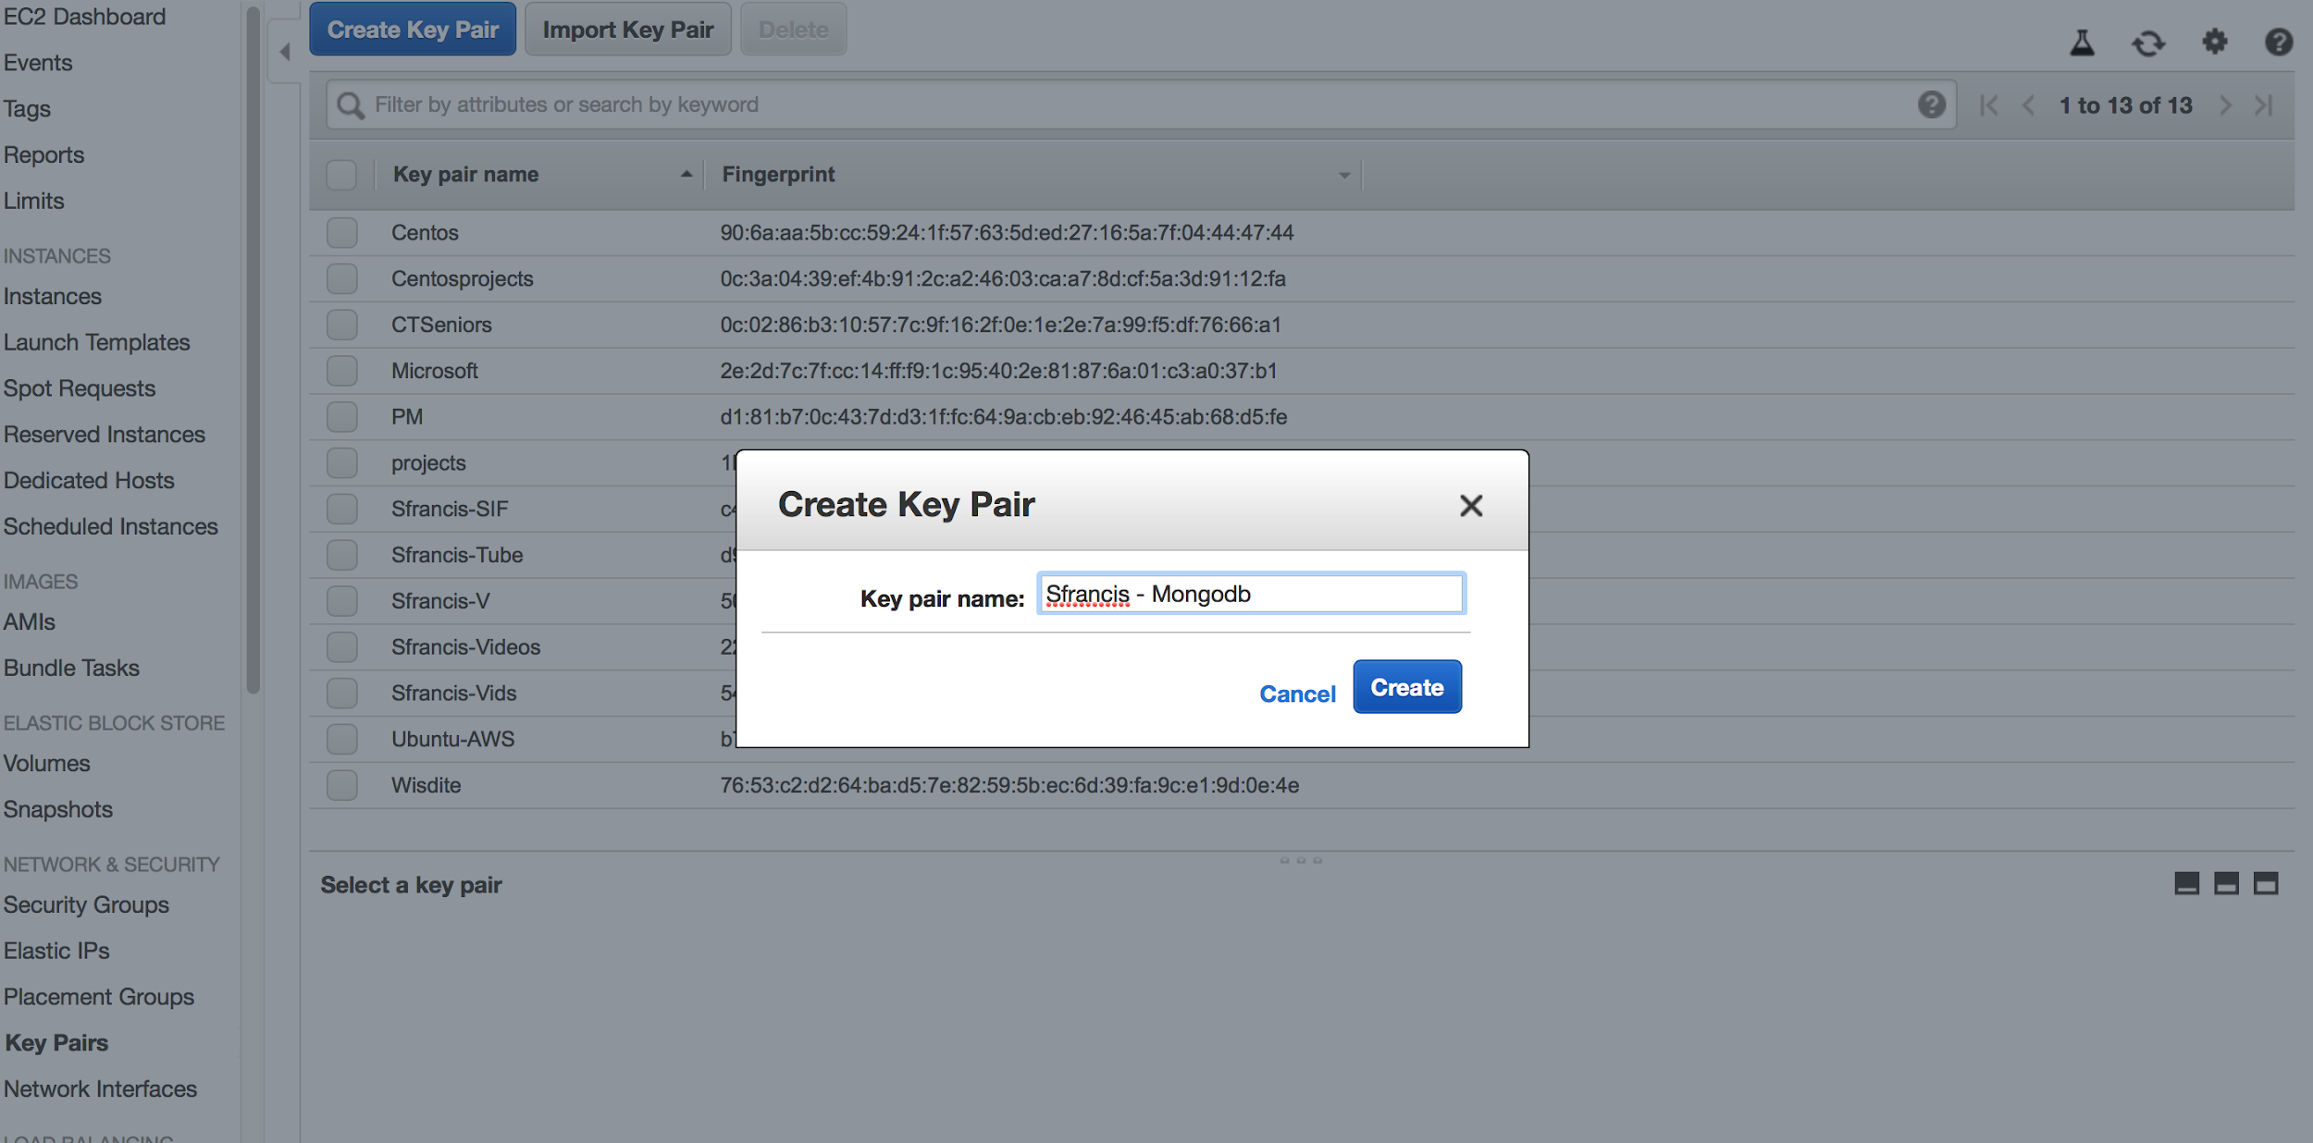

**Step 2:** Download the PEM file from AWS, rename it as a **.pem** extension

**AS-IS** **TO-BE**

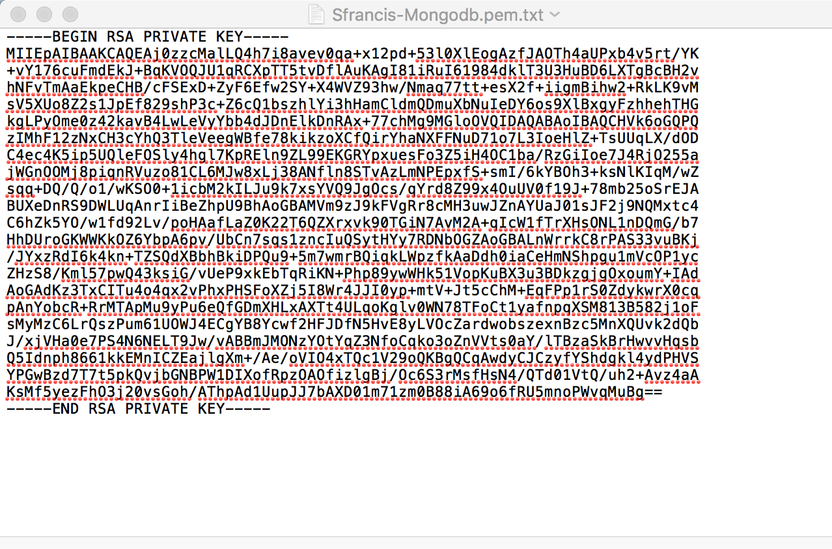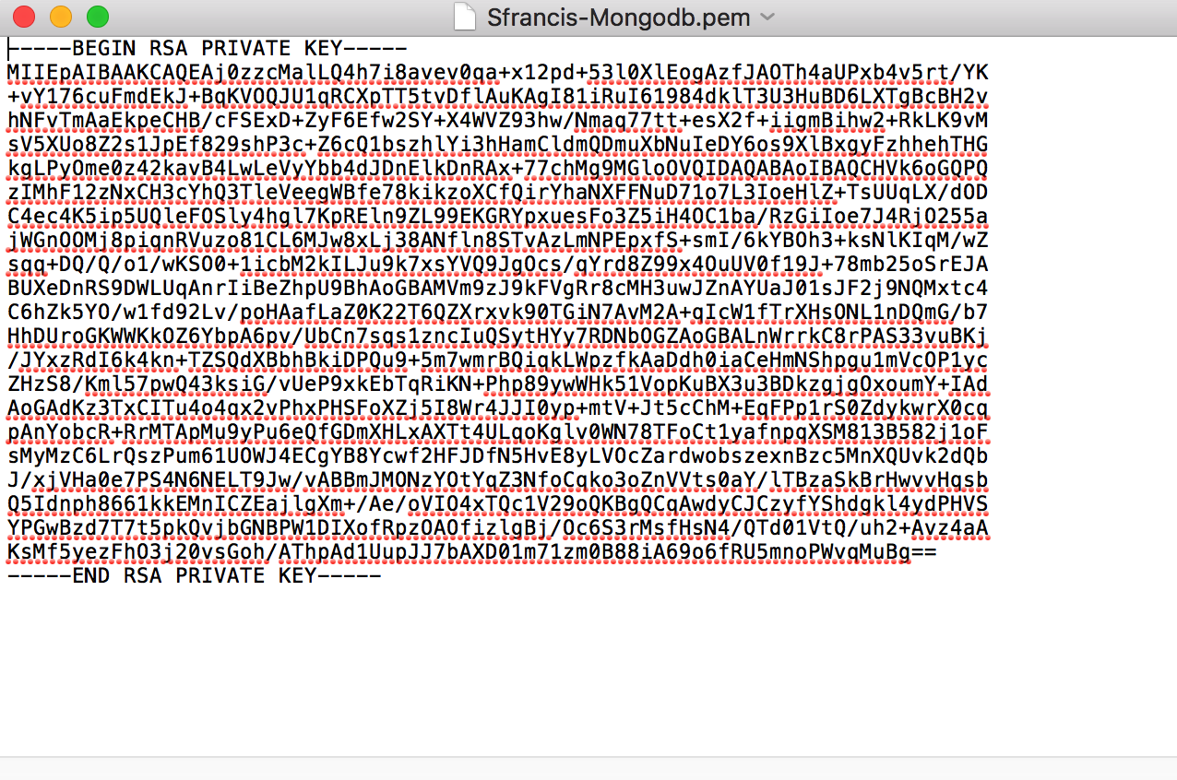

**Step 3:** Save the .pem file in your .ssh directory

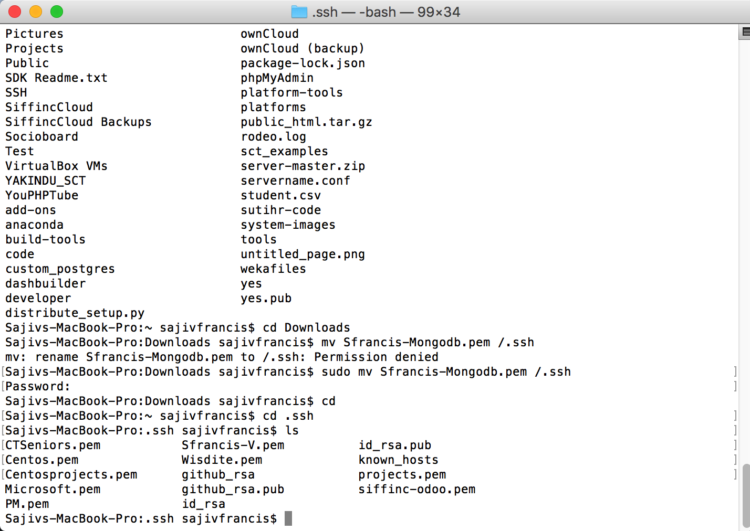



**Step 4:** SSH into your server instance

**Example:** ssh -i /Users/sajivfrancis/.ssh/Sfrancis-Mongodb.pem ubuntu@ec2-34-211-XX-2XX.us-west-2.compute.amazonaws.com

#**df -h** (Use this command to understand filesystem size and partitions on your server, have adequate space for mongodb to run on your instance)

Now you can log into your AWS instance and start configuring Mongodb, there might be a few server administrative tasks that need to be done such as creating users, setting up your bash_profile and other server administration tasks for an optimal Mongo installation.

## **Installation of Ubuntu (MAAS) on Premise: Metal as a service**



**Note:** Double click the image to play the video

**Ubuntu Server set up as a MAAS - On premise**

### 

### 

### 

### **Steps for MAAS Installation:**

Step 1: # SSH into your ubuntu server

Follow steps from AWS installation process: INSTALLATION ON AWS:

Step 2: # sudo apt -y update

Step 3: # sudo apt -y upgrade

Step 4: # sudo apt install maas

Install additional components/packages that are required for MAAS

**Network Topology:**

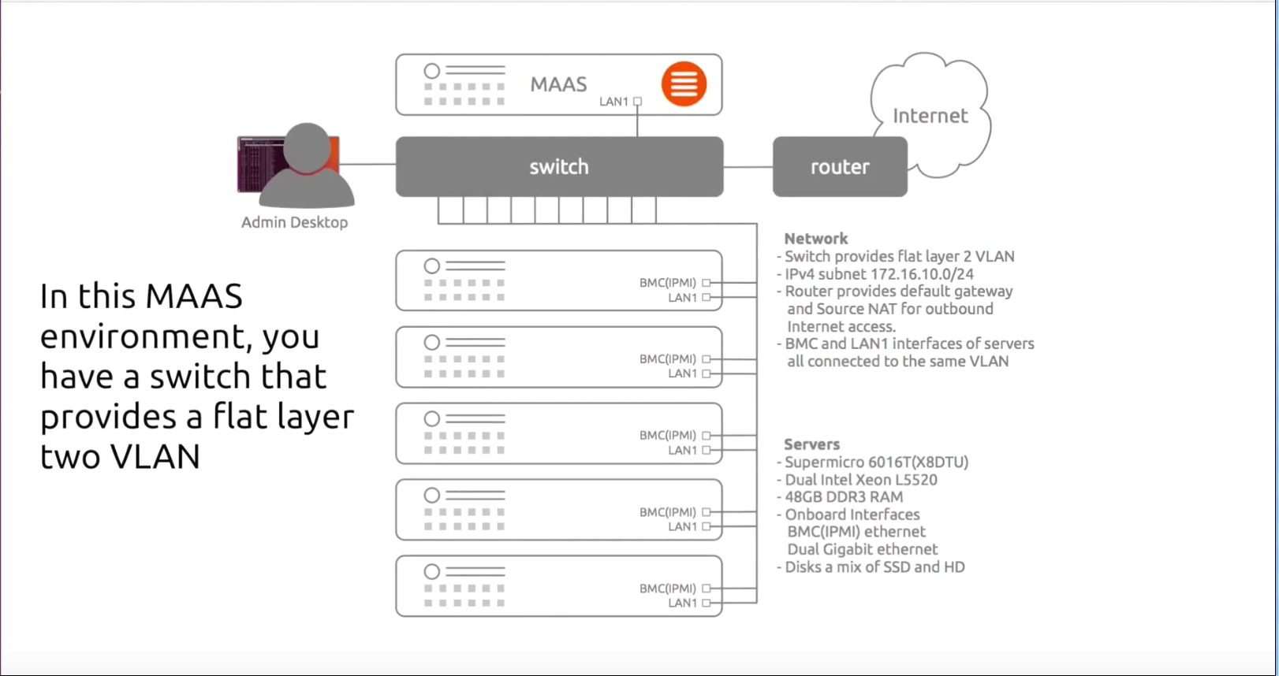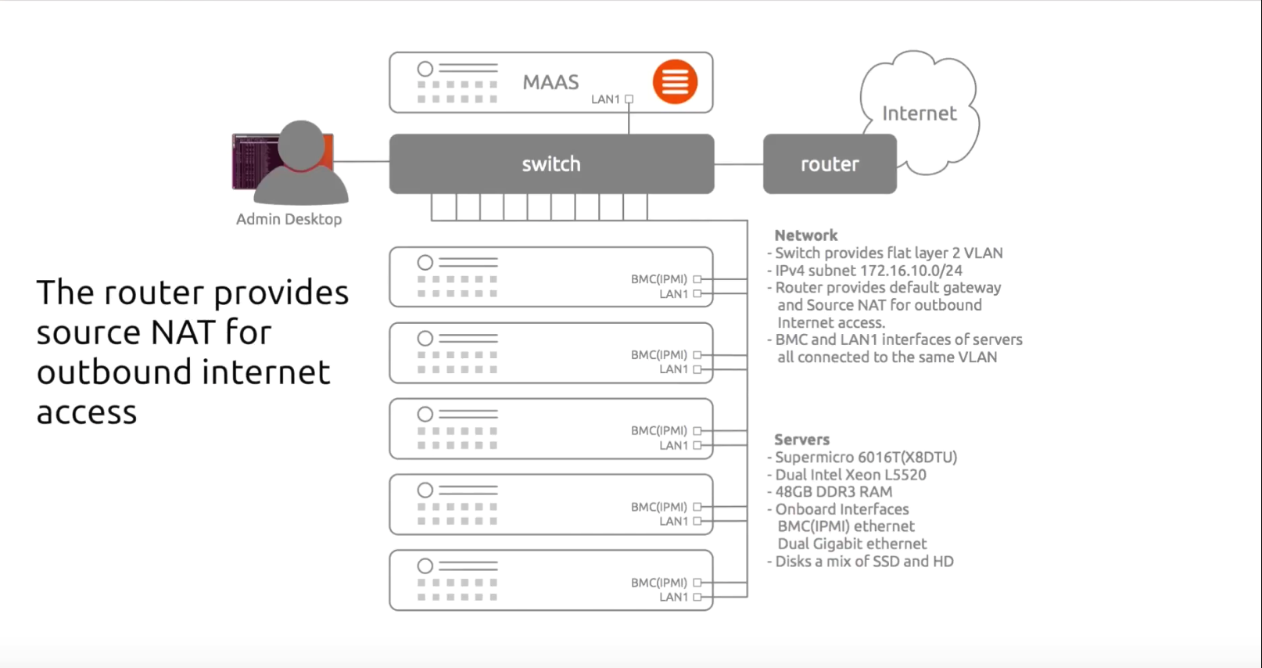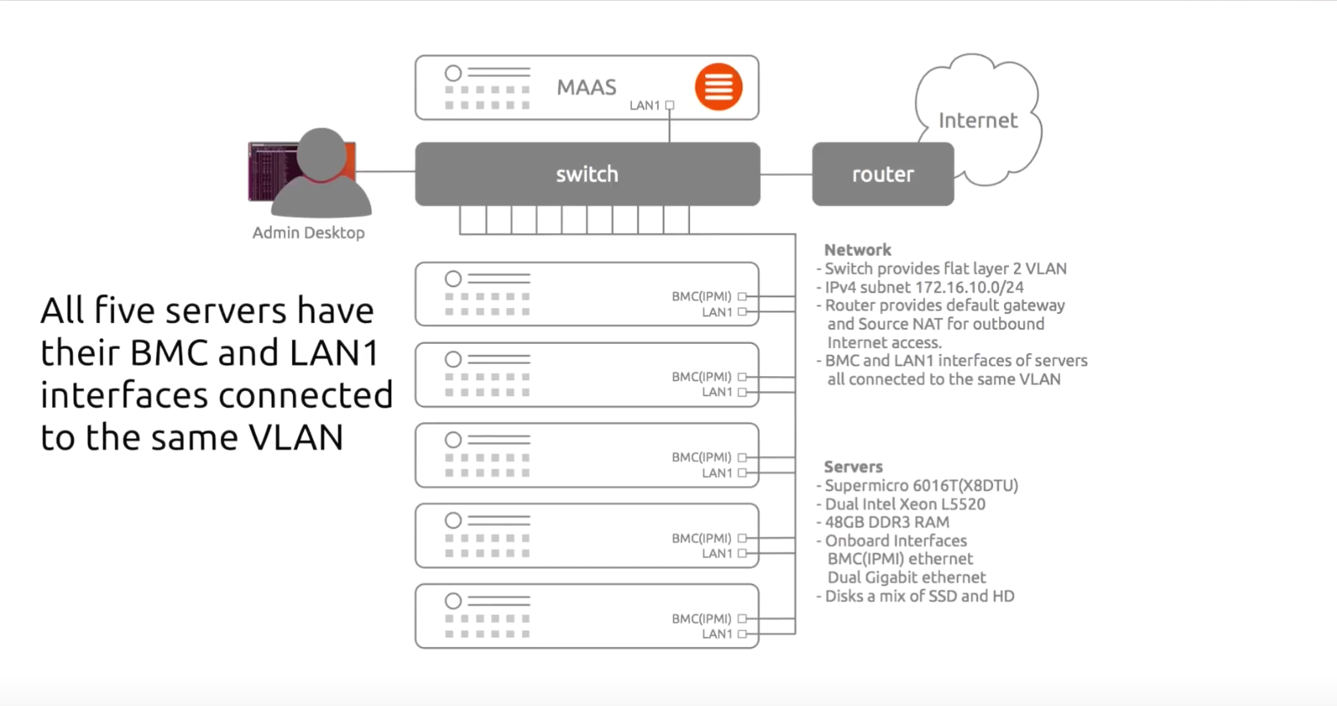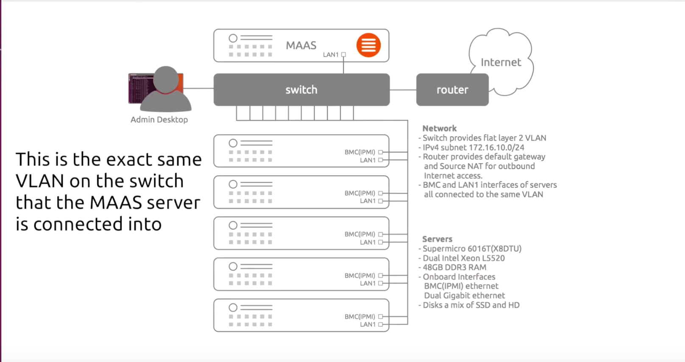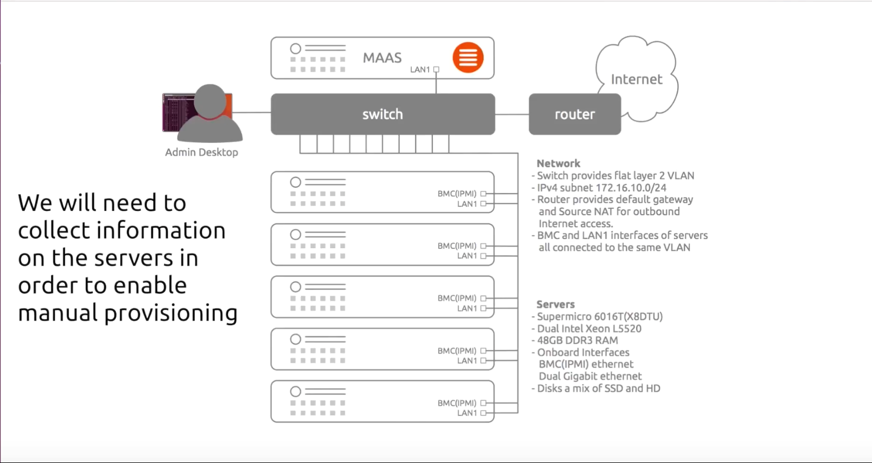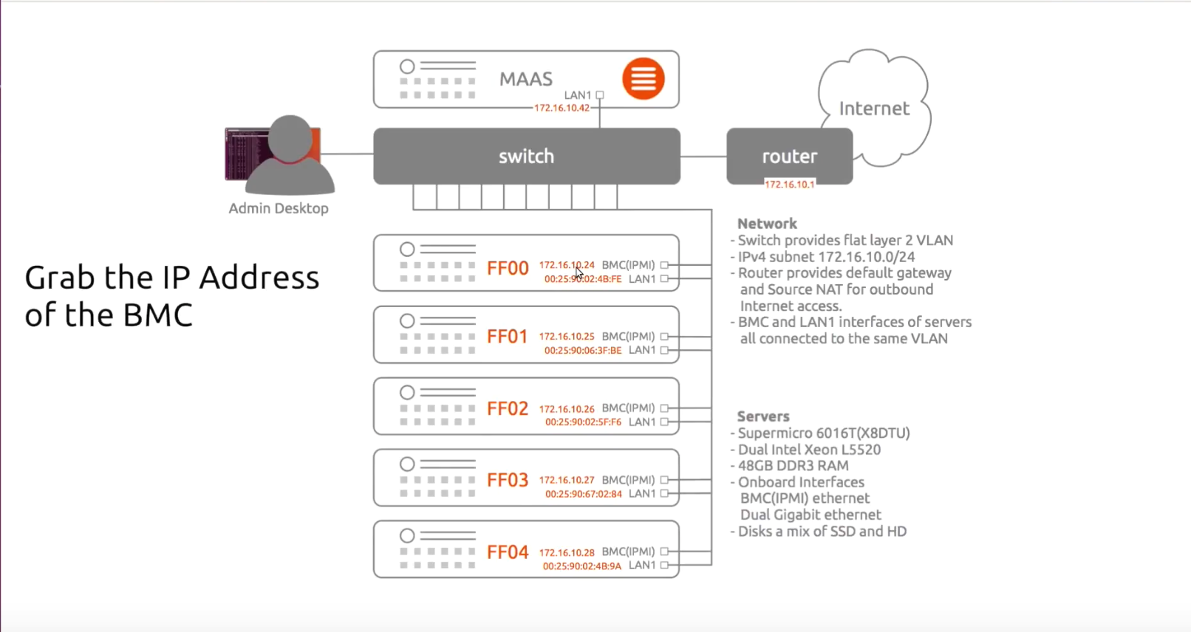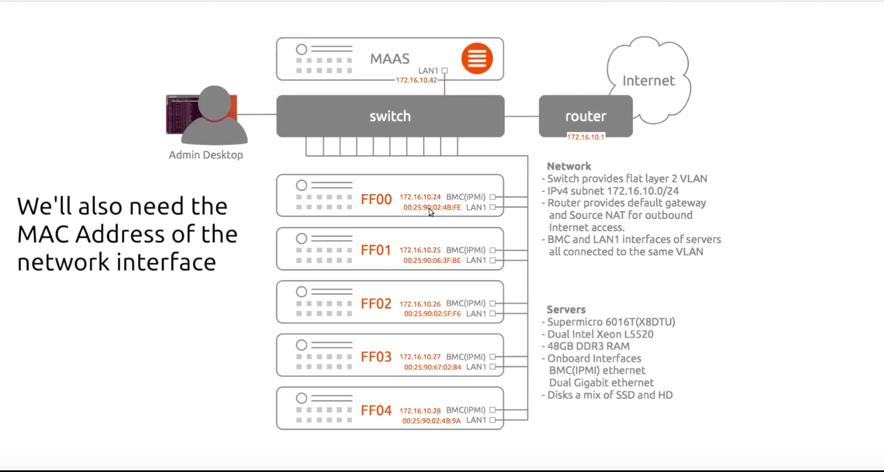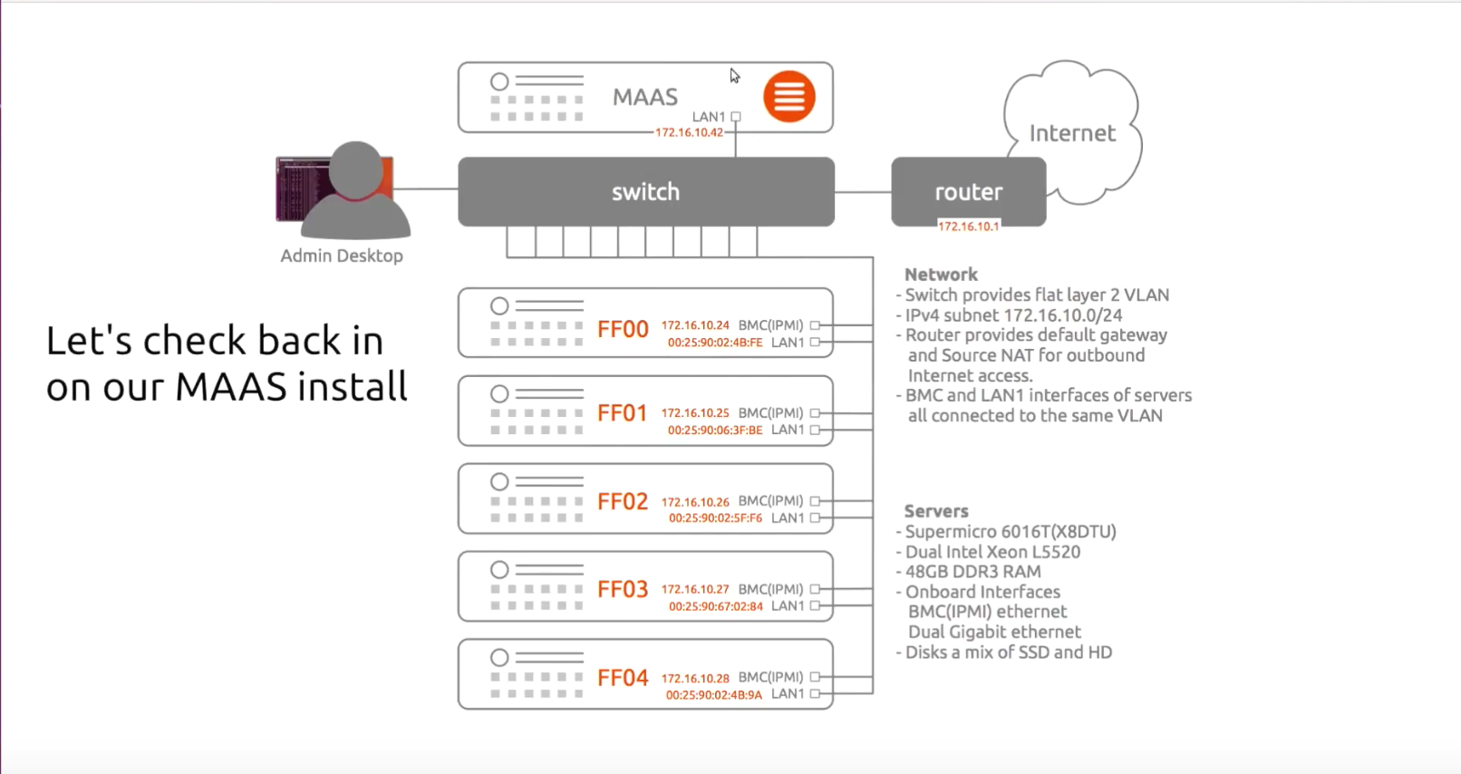

**Step 5:** # sudo mass createadmin

**Username:** XX

**Password:** XXXXXXX

**Email:** [XX@XX.com](mailto:XX@XX.com)

**Import SSH Keys [] (lp:user-id or gh:user-id): #** lp:sfrancis-7567 or gh:sfrancis-5656

(MAAS allows you to import SSH keys from launchpad or github)

**Step 6:** Access MAAS user interface

http://<your.mass.ip>:5240/MAAS/

(**e.g.** IP address of your AWS instance or stand alone on premise server)

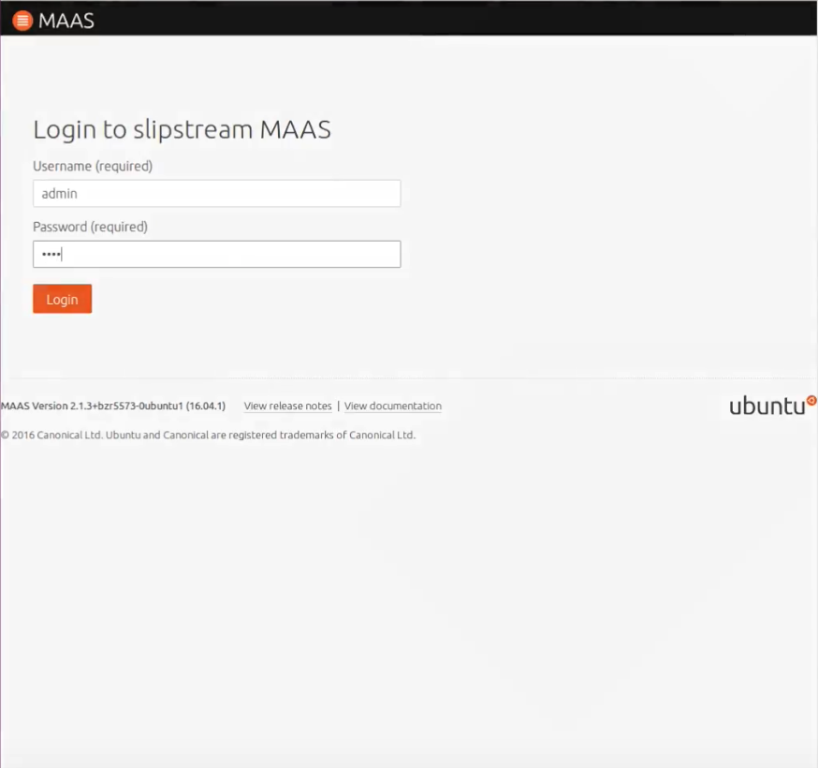

# MONGODB:

## **ABOUT MONGODB:**

- MongoDB is a cross-platform, document oriented database.

- MongoDB provides **high performance**, **high availability**, and **easy scalability**.

- MongoDB works on concept of **Collection** and **Document**.

**Database**

Database is a physical container for collections. Each database gets its own set of files on

the file system. A single MongoDB server typically has multiple databases.

**Collection**

Collection is a group of MongoDB documents. It is the equivalent of an RDBMS table. A

collection exists within a single database. Collections do not enforce a schema.

**Documents**

Are within a collection and can have different fields. All documents in a collection are for similar or related purpose. A document is a set of key-value pairs. Documents have dynamic schema. Dynamic schema means that documents in the same collection do not need to have the same set of fields or structure, and common fields in a collection's documents may hold different types of data.

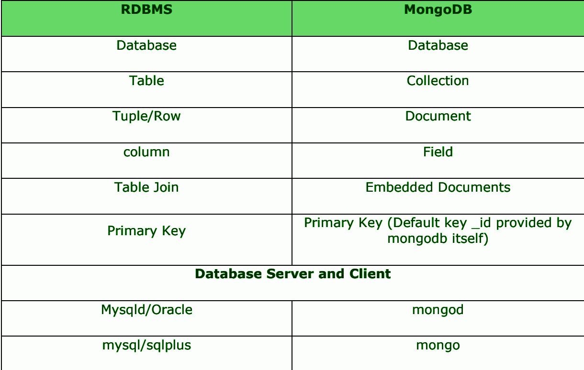

## **Acid Theorem:**

### **What is ACID: -** It is a rule and meant a lot for RDMBS because all RDBMS are ACID compliance.

### **A=Atomicity**, means all or nothing, if I own a session and fire two updates to my transaction that means they all succeed , it never be the case when one of my update success and another failed. **C=Consistency:-** All transaction to database will bring database from one valid database state to another and once data pass all defined rules like constraints, triggers or any other rule, it become permanent and acquire another database state. But if programmer want any application specific rule it does not guaranty, simple because database don’t know your business case either define it on database level or take care at application level, otherwise it would not be consistent according to your business rule. **I=Isolation: -** RDBMS are full with latches and locking, and locking and latching. All to achieve concurrency and there are various other ways to achieve concurrency is serialization isolation level, strict and read only. We get phantom reads, dirty reads and many other if isolation levels are not followed. **D= Durable: -** It means when transaction is committed it will remain in this valid state till next valid state occurs. In case of any loss to power or crash can be recovered by solution.

## 

## **CAP Theorem:**

### **What is CAP: -** The CAP theorem states that a distributed (or shard data) system can offer two out of three desired properties – Consistency, Availability and Tolerance to Partitions

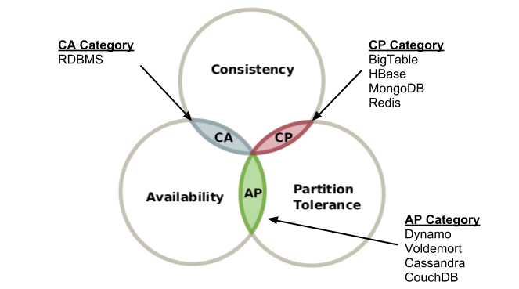  
   
**C= Consistency** have different mean here, it is basically if someone writes a value to a database, thereafter other users will immediately be able to read the same value back. If Consistency is violated, then you’ll get the case where one user will get a different answer from another: if user A makes a request and it gets routed to node X, and user B makes a request and it gets routed to node Y, and X and Y have different data, A and B will get different answers.  
**A=Availability** means that if some number of nodes fail in your cluster the distributed system can remain operational. If Availability is violated, it means that any node might go down at any time, and that a request made to that node might just never return a response. Alternatively, if a sibling node had just been updated, it would mean that a node would refuse to respond to requests until itself was updated to reflect the most recent state.  
**P=Tolerance to partitions**, means that if the nodes in your cluster are divided into two groups that can no longer communicate by a network failure, again the system remains operational. If Partition tolerance is violated, it means that a single node going down could take even more nodes down with it, and that a failure in one part of the system could spread.

## **ADVANTAGES OF MONGODB:**

Any relational database has a typical schema design that shows number of tables and the relationship between these tables. While in MongoDB, there is **no concept of relationship.**

* **Schema less:** MongoDB is a document database in which one collection holds different documents. Number of fields, content and size of the document can differ from one document to another.
* Structure of a single object is clear.
* No complex joins.
* **Deep query-ability:** MongoDB supports dynamic queries on documents using a document-based query language that's nearly as powerful as SQL.
* Tuning.
* Ease of scale-out: MongoDB is easy to scale.
* Conversion/mapping of application objects to database objects not needed.
* Uses internal memory for storing the (windowed) working set, enabling faster access of data.

### **What are the uses of MongoDB?**

- Document Oriented Storage: Data is stored in the form of JSON style documents.

- Index on any attribute

- Replication and high availability

- Auto-sharding

- Rich queries

- Fast in-place updates

- Professional support by MongoDB

### **What environment needs MongoDB?**

- Big Data

- Content Management and Delivery

- Mobile and Social Infrastructure

- User Data Management

- Data Hub

## **INSTALLATION OF MONGODB ON LINUX (Ubuntu):**

The following steps are once you have a running instance of Ubuntu on either the cloud or on premise

**Note:** See steps to install ubuntu on AWS - INSTALLATION ON AWS:

**Note:** See steps to install ubuntu on bare metal (on premise) - INSTALLATION OF UBUNTU (MAAS) ON PREMISE: METAL AS A SERVICE

### **Server steps from commandline:**

**Download and Install the Latest Updates for the OS**  
# apt-get update && apt-get upgrade -y

# lsb_release -a (information about the ubuntu release)

# uptime (time since the instance has been up)

# df -h (server partition information)

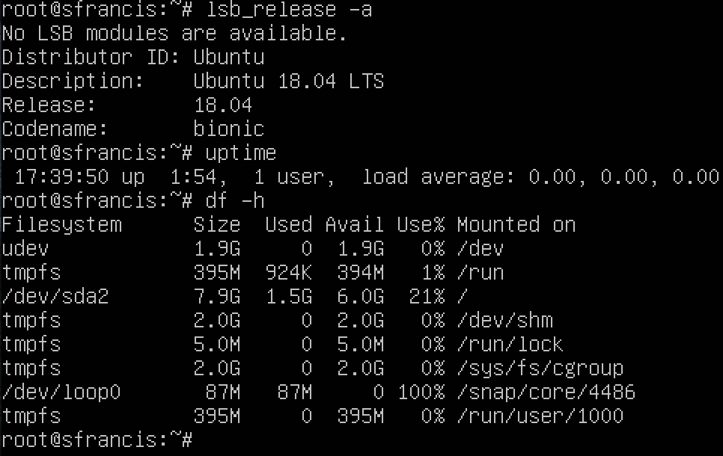

**Set the Server Timezone to EST**

# echo "America/Newyork" > /etc/timezone  
# dpkg-reconfigure -f noninteractive tzdata  
  
**Enable Ubuntu Firewall and allow SSH**

# ufw enable  
# ufw allow 22  
# ufw allow 80  
# ufw allow 443  
# ufw allow 27017  
# ufw allow 27018  
# ufw allow 27019  
# ufw allow 28017  
  
**Install essential packages**

# apt-get -y install git zsh curl htop  
  
**Install MongoDB Server:**

**Import the public key from the keyserver maintained by MongoDB**

# apt-key adv --keyserver hkp://keyserver.ubuntu.com:80 --recv 7F0CEB10 or EA312927 (import public key from mongodb keyserver)  
# echo 'deb http://downloads-distro.mongodb.org/repo/ubuntu-upstart dist 10gen' | sudo tee /etc/apt/sources.list.d/mongodb.list

(or)

# echo 'deb <http://repo.mongodb.org/apt/ubuntu> xenial/mongodb-org/3.2 multiverse” | sudo tee /etc/apt/sources.list.d/mongodb-org-3.2.list

# apt-get update  
# apt-get install mongodb-10gen

## **START & REMOVE MONGODB SERVICE ON UBUNTU:**

Type the following commands:

### **Step 1: Check if the service is running:**

# mongo & # ls -l /lib/systemd/system/mongo*

Create mongod.service file that will automatically start the mongo instance on restart

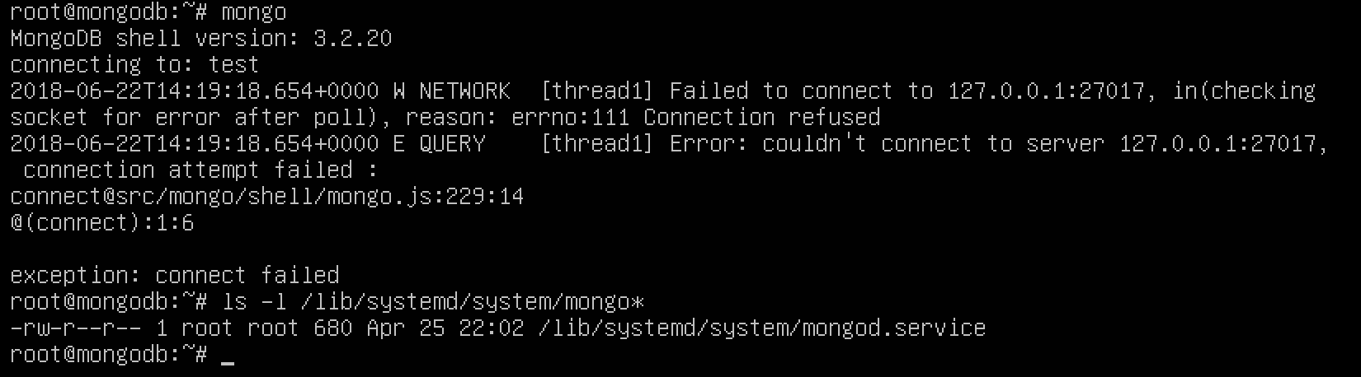

### **Step 2: Status of Mongo instance**

# service mongod start (**Note:** Linux daemon services end with D. e.g. mongod)

# service mongod status

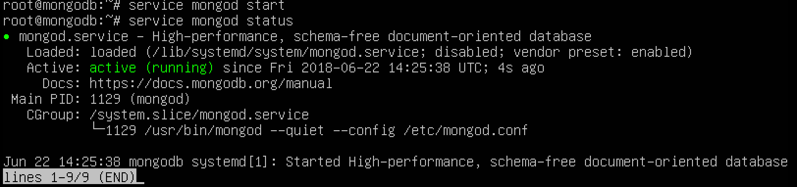

# mongo

# show dbs

### **Step 3: Stop the Mongodb service or Uninstall mongodb on ubuntu**

# service mongod stop

# sudo apt --purge remove mongodb-org

# rm -r /var/log/mongodb/ **&&** # rm -r /var/lib/mongodb/

## 

## **MONGODB CONFIGURATION:**

### **About mongod.conf:**

The mongo configuration file can be changed to adjust your operating environment using the conf file or it can be done from the commandline; it is recommended to adjust your mongo operating environment using the configuration file - it provides a means to record changes to your mongo instance.

# mongo

# show dbs

### **Path to mongo configuration file:**

# cd /etc

# ls -l mongo*

# cp mongod.conf mongod.conf.backup

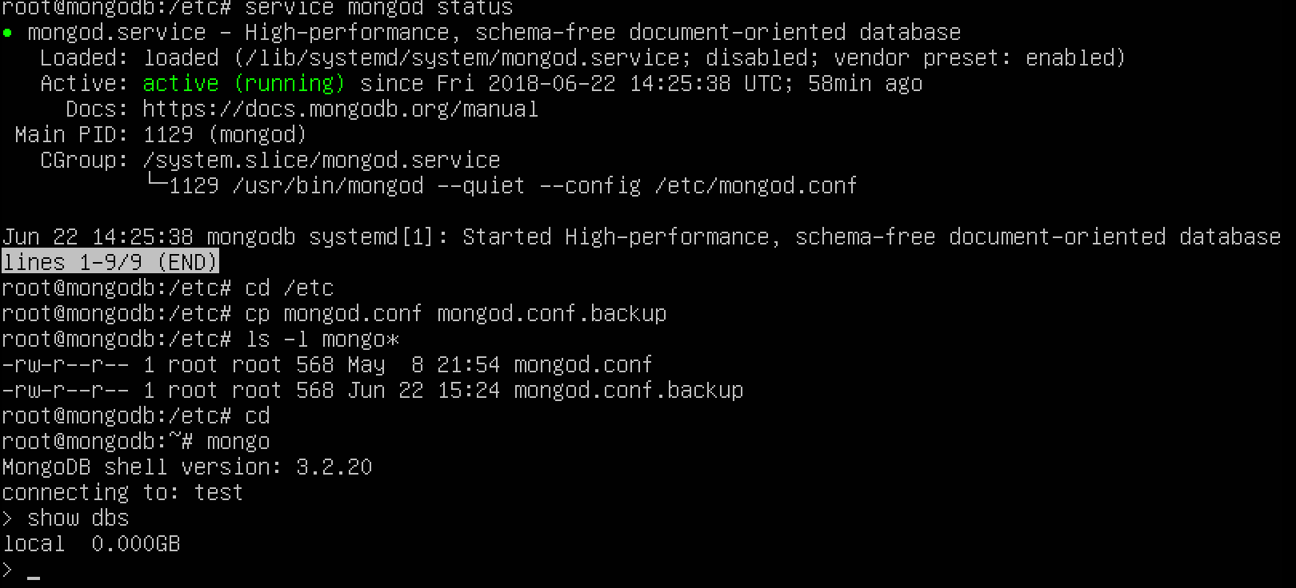

### **Move your data directories into your home file system:**

**(Separate from root in case of system crashes, updates, operating system changes or to reconnect to your database in case of failure):**

# df -h

### **Default Mongo database location:**

# cd /var/lib/mongodb

# ls -l

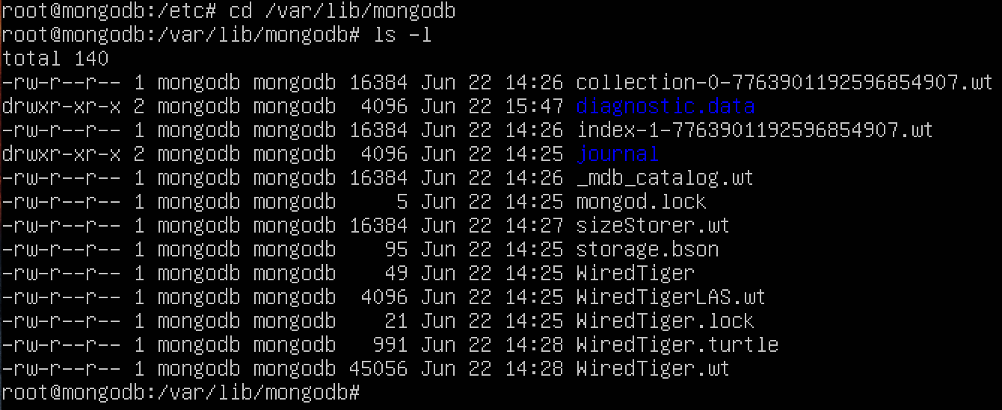

### **Stop the Mongo database:**

# sudo service mongod stop (ubuntu) & systemctl stop mongodb (centos)

# lsof -i | grep mongo (ubuntu) & ps -ef | grep i mongo (centos)

### **Append the mongod.conf file to change your dbPath location:**

# **nano /etc/mongod.conf**

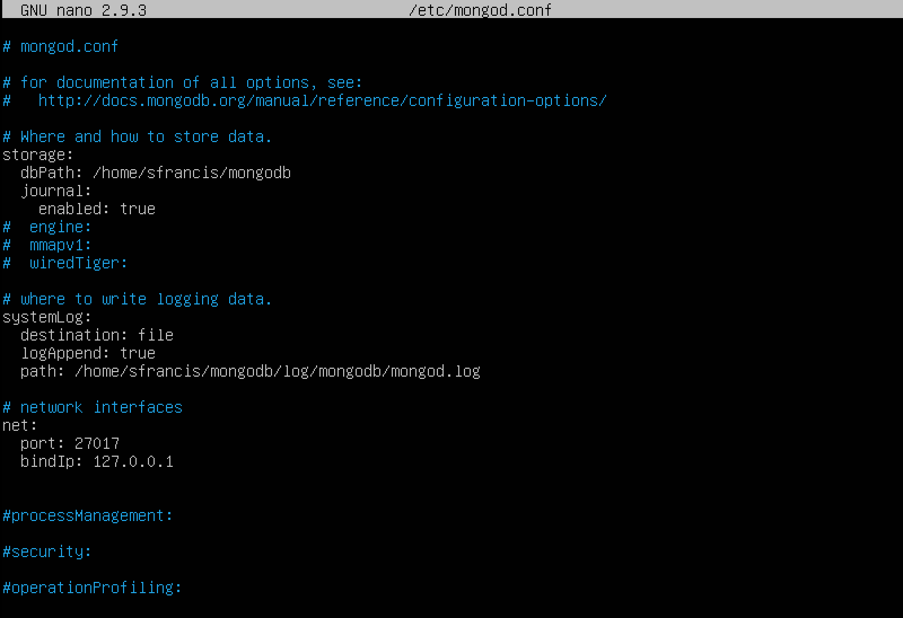

### **Copy mongodb data files to your home directory:**

**Note:** pvR (copy all permissions over to new location)

# **cp -pvR /var/lib/mongodb/ /home/sfrancis/mongodata**

Check to ensure all the data directory files are copied

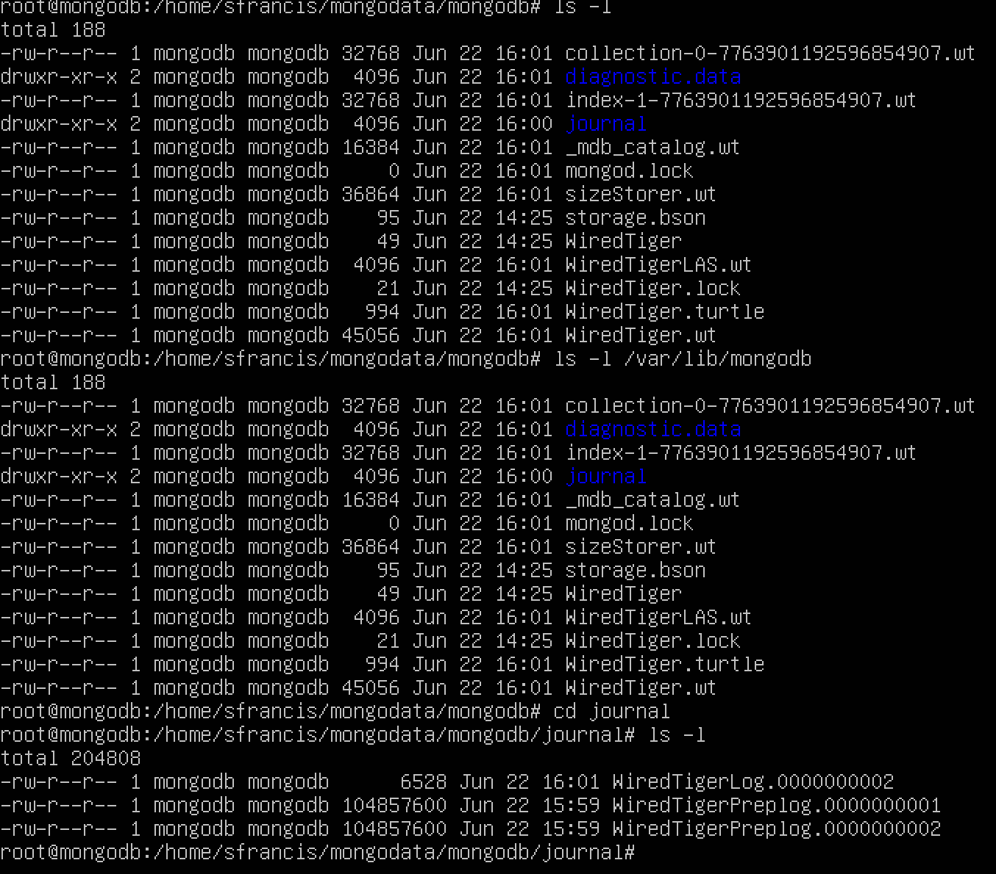

### **Rename the original mongodb repository to a new location:**

**Note:** The below commands will ensure that on startup - mongo will look for the yaml/data directory files from the path that you had specified in previous steps. Start the database using the systemctl command instead of by the root, they are a few initial Wired Tiger files that are created when the root forks off the mongodb process.

# cd /var/lib

# mv mongodb/ mongodb.original

**To restart the mongo service use the following command:**

# sudo systemctl enable mongod

# sudo service mongod restart

### **Issues faced:**

The mongod service failed to restart due to unknown errors:

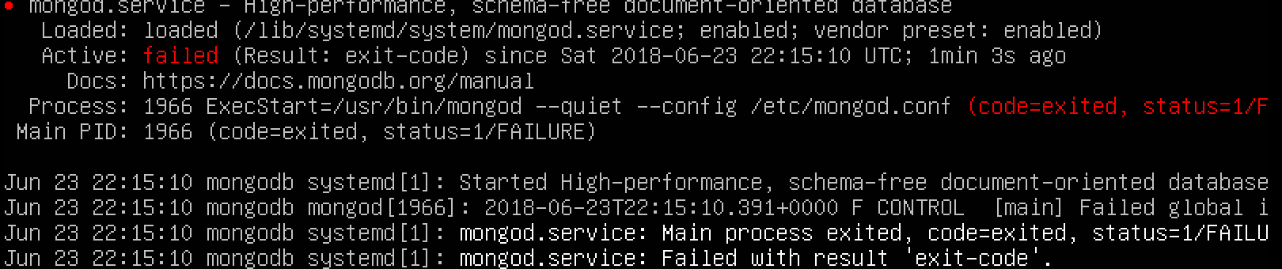

**Steps taken:**

1. Read the log files to identify any error, we were unable to find errors on the log file since they were not being written in the new log path specified in the mongod.conf file at /etc/mongod.conf
2. On further troubleshooting, we found that the issue was due to the mongodb user not having permission to write in the directory created for the data & log files.

# chown -R mongodb:mongodb /home/sfrancis/mongodata

# chown -R mongodb:mongodb /home/sfrancis/mongodata/*

The above two commands fixed the issue and you can see the output after mongo start:

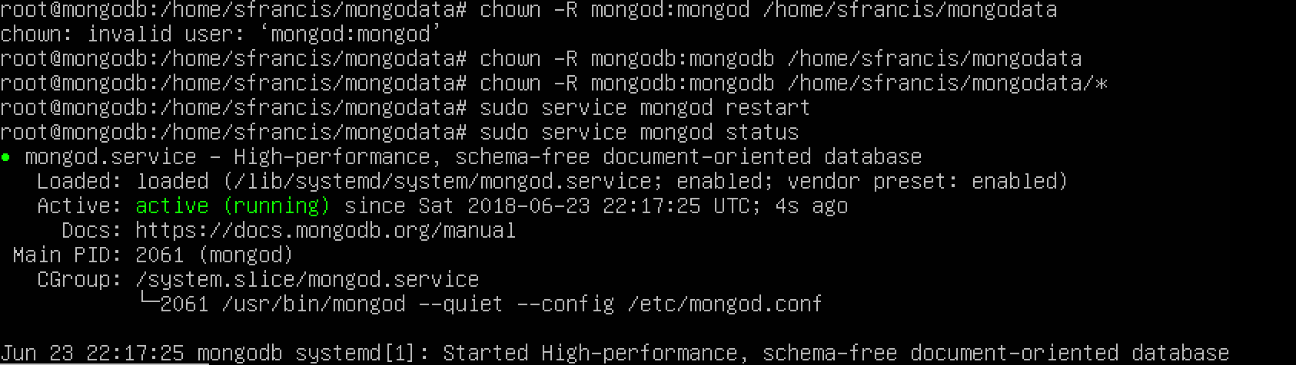

## **REPLICATION CLUSTERS:**

### **What is Replication?**

Replication is the process of **synchronizing data across multiple servers.**

### **How does replication help?**

- Replication provides redundancy and increases data availability.

- Multiple copies of data are made available on different database servers.

- Replication protects a database from the loss of a single server.

- Replication also allows you to recover from hardware failure and service interruptions.

- Additional copies of the data allows you to dedicate one to disaster recovery, reporting,

or backup etc.

### **Why do we do replication of nodes in mongodb?**

* To keep your data safe
* High (24*7) availability of data
* Disaster recovery
* No downtime for maintenance (like backups, index rebuilds, compaction)
* Read scaling (extra copies to read from)
* Replica set is transparent to the application

### **How Replication Works in MongoDB?**

MongoDB achieves replication by the use of **replica set.** A replica set is a **group of mongod instances that host the same data set**. In a replica, one node is primary node that receives all write operations. All other instances, such as secondaries, apply operations from the primary so that they have the same data set. Replica set can have only **one primary node**. Replica set is a group of two or more nodes **(generally minimum 3 nodes are required but can have odd increment of 5,7, or 9 nodes etc).**

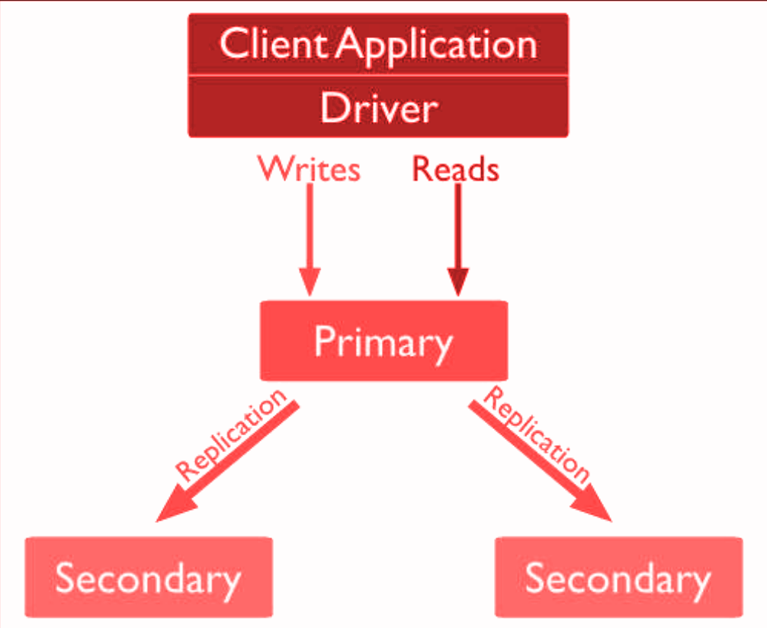

## **REPLICATION CONFIGURATION:**







### **Steps to configure our standalone instance into a Replica Set:**

**Step 1:** Stop the mongod instance on your server.

# sudo service mongod stop

**Step 2:** Copy the mongod.conf file to your desired location & make necessary changes to the config file.

# cp /etc/mongod.conf /home/sfrancis/mongoReplsets/ProjectOne/serverCA/conf

Sample file and location:

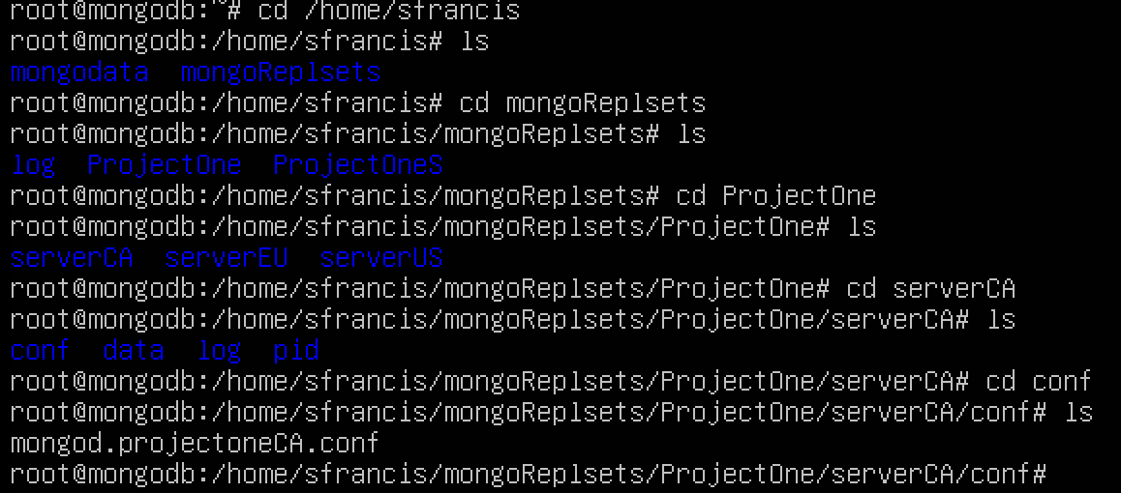

**Step 3:** Edit the mongod.projectoneCA&US&EU.conf file with necessary changes as below:

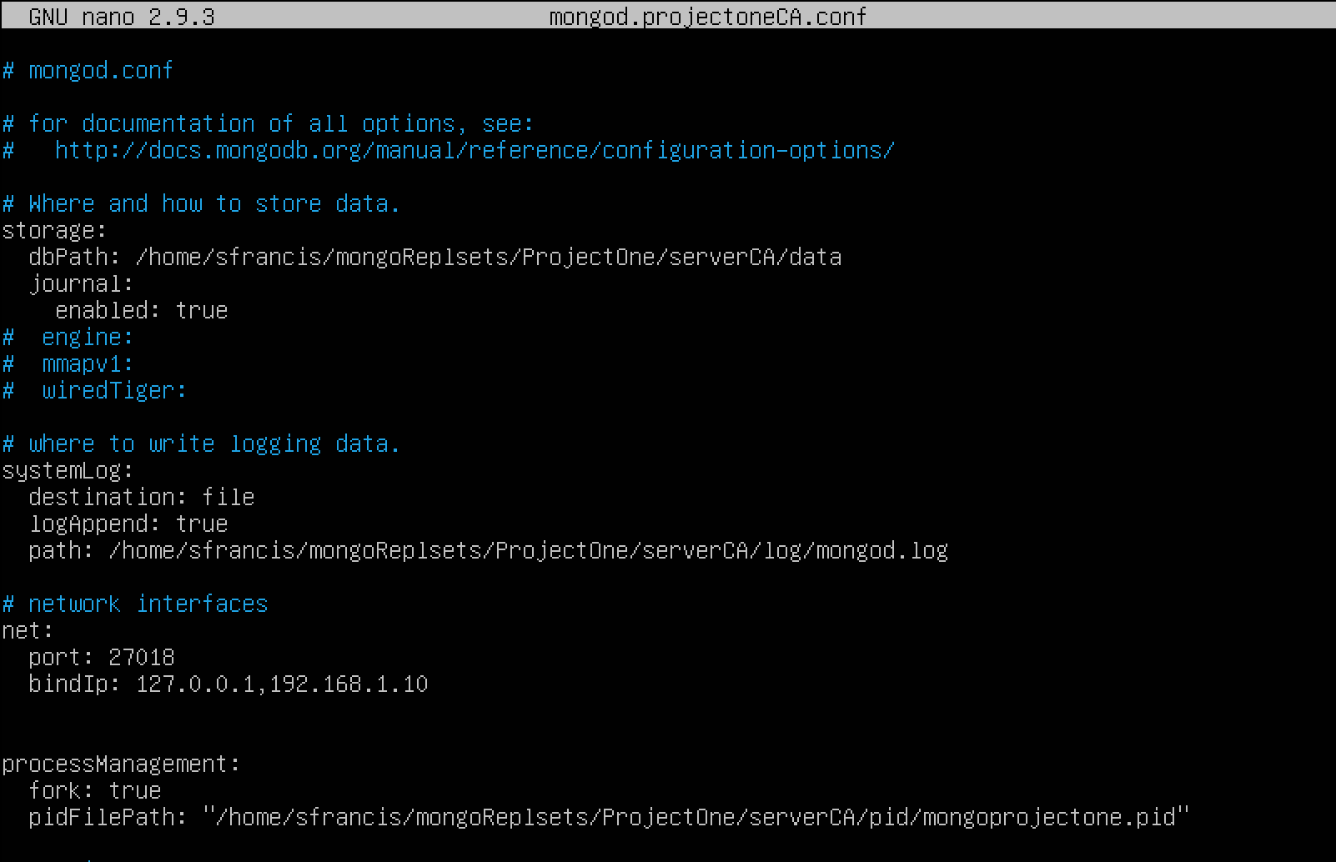

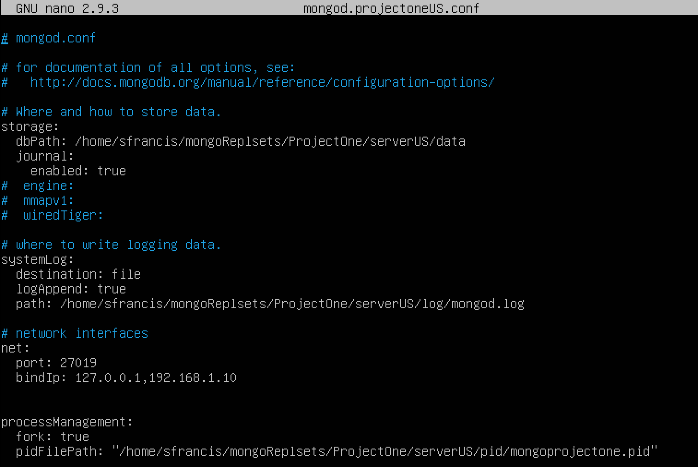

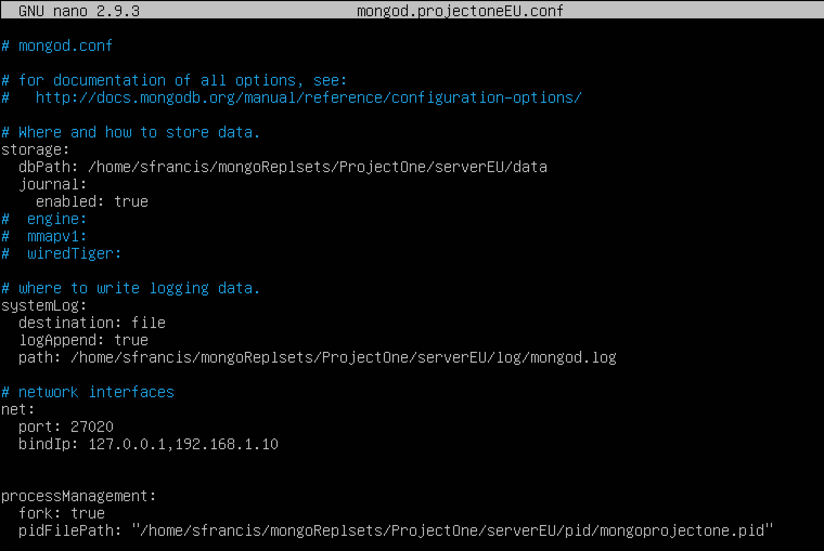

**Step 4:** Start up mongo as a service with following commands:

**Primary server: Canadian**

# sudo -u mongodb mongod -f /home/sfrancis/mongoReplsets/ProjectOne/serverCA/conf/mongod.projectoneCA.conf

**Secondary server: United States**

# sudo -u mongodb mongod -f /home/sfrancis/mongoReplsets/ProjectOne/serverUS/conf/mongod.projectoneUS.conf

**Secondary server: European Union**

# sudo -u mongodb mongod -f /home/sfrancis/mongoReplsets/ProjectOne/serverEU/conf/mongod.projectoneEU.conf

**Step 5:** Once the child process starts successfully, run the following command to check the mongo instances running on the server.

# ps -ef | grep -i mongo

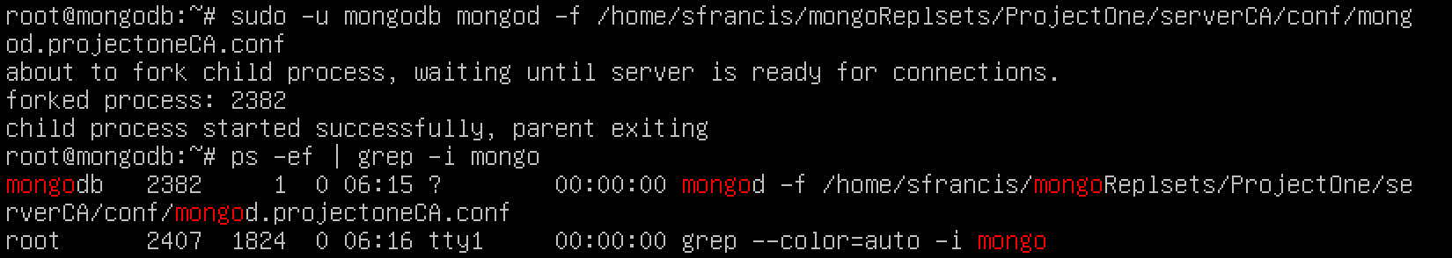

### **Issues Faced:**

**Step 6:** Run the ‘mongo’ command to enter into the primary mongo instance

**Error:**

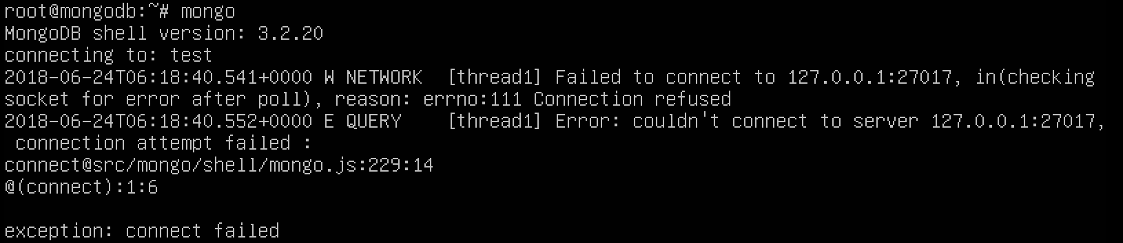

The above error is due to mongo listening to the original standalone instance port# 27017. Our replication sets have port numbers configured to 27018, 27019 and 27020.

Step 7: Run the following command to point mongo to run on the right port (“27018”)

# mongo --port 27018

**# rs.initiate()** (run this command on the primary server node)

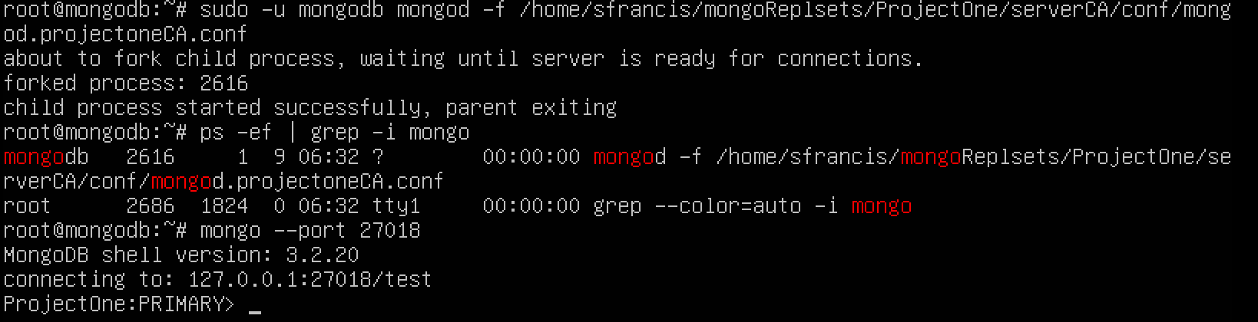

**Step 8:** Run the following commands (if not done previously) for the other 2 secondary server nodes as well.

**Secondary server: United States**

# sudo -u mongodb mongod -f /home/sfrancis/mongoReplsets/ProjectOne/serverUS/conf/mongod.projectoneUS.conf

**Secondary server: European Union**

# sudo -u mongodb mongod -f /home/sfrancis/mongoReplsets/ProjectOne/serverEU/conf/mongod.projectoneEU.conf

# mongo --port 27018 **(make sure mongo listens to the primary instance running on 27018)**

# mongo

# rs.add(“192.168.1.10:27019”)

# rs.add(“192.168.1.10:27020”)

# rs.status()

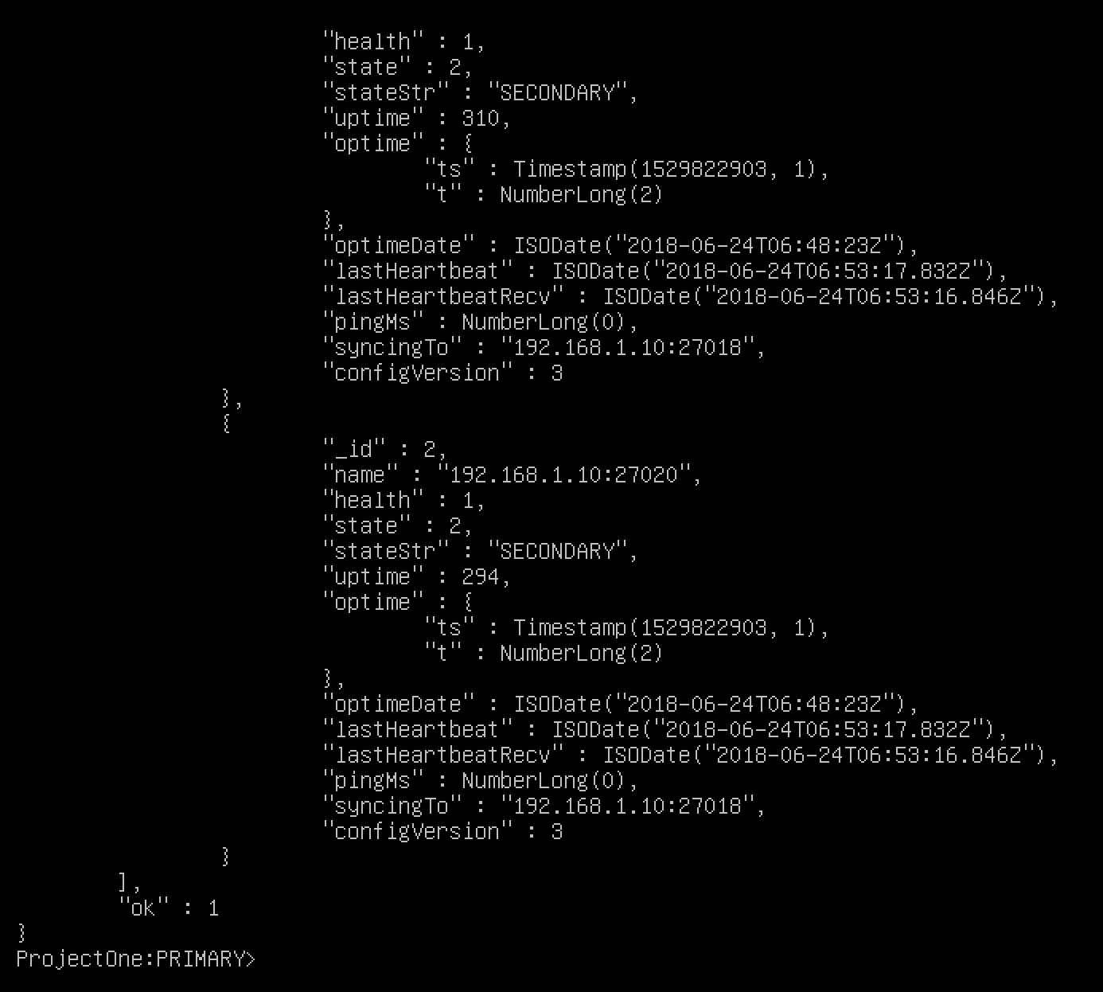

### **Adjust priority for the Replication Set:**

**Step 1:** Check the priority of your nodes with the following command.

# rs.conf()

The result is that all the nodes in your replset have a priority: 1 allocated to them.

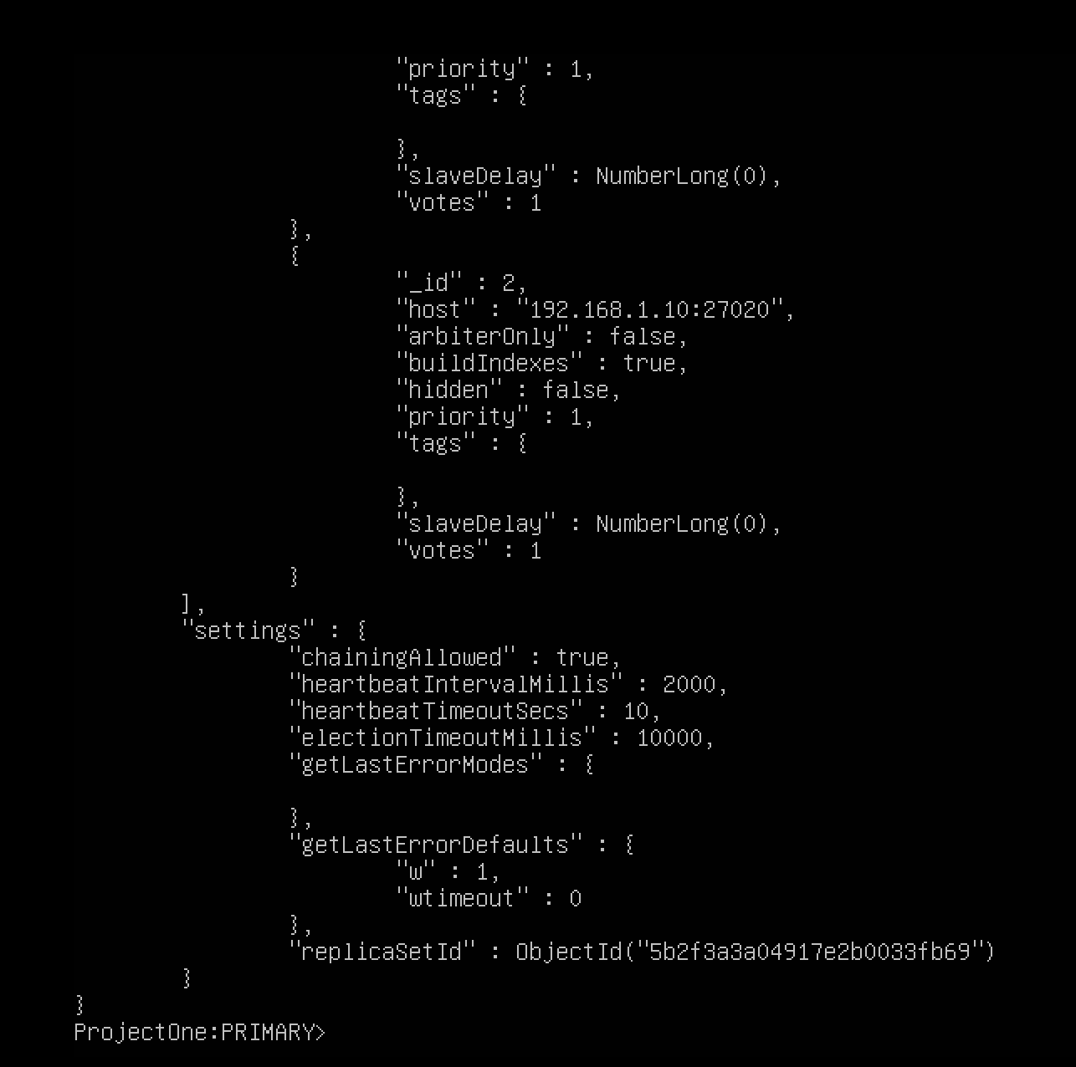

**Current mongo instances:**

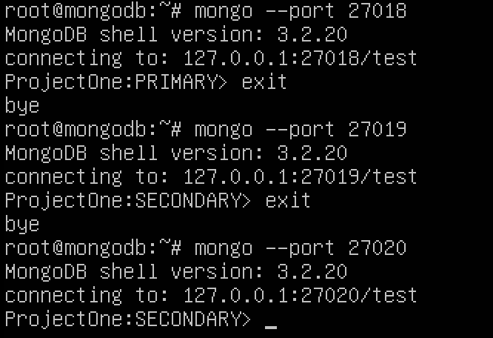

27018 = **serverCA**, 27019 = **serverUS** and 27020 = **serverEU. “Our goal is to move the serverUS as the primary with command from step 2 and the following:”**

**Step 2:** Electing the serverUS as the primary. Take the output from the cfg command and assign it to a variable. This results in the output from rs.conf being assigned to config. Check the configuration has been assigned by using the ‘cfg’ command.

# cfg = rs.conf()

# cfg (This will allow you to tweak any of the parameters stored in the variable **( parameters can be found after running the ‘cfg’ command, it is within the members array)).**

**Take note of the id # of each member, at this point, 0 is Canadian, 1 is USA and 2 is Europe.**

**Step 3:** Increase the priority value within a member ID to make it the primary server on restart.

#cfg.members[1].priority = 10 (Member ID# 1 is for node running in USA)

Propagate the change out to the configuration:

#rs.reconfig(cfg)

#rs.conf() (This will not work since **serverCA (port 27018)** has been demoted to secondary)



(Enter the following command for **serverUS (port 27019)**, which is the new primary)

# **exit**

# **mongo --port 27019 (your new primary - serverUS)**

## **SHARDING:**

### **What is Sharding?**

* Sharding is a process that stores collection or database records across multiple physical machines or nodes.

### **Why do we utilize sharding in MongoDB?**

* As with any database, the database likes to keep all indexes in memory. Very large collections can cause exhaustion of memory, disk-storage, CPU or all of the above.
* In Replication, all writes go to one node (the master), in sharding, writes are distributed across all master nodes. Replication set is limited to 12 nodes with one master, shards are not limited.
* Very large datasets (indexes) cannot be fully contained in memory, local disk space might not be sufficient.

### **How does Sharding help?**

- Sharding is a form of scaling that allows you to project a collection (or database) across several computers.

- A shard is a fragments ( meaning broken earthenware)

- Shards are pieces of your collection or database spread across two or more computer/servers(nodes).

**Review of MongoDB Replication sets ( a maximum of 12 nodes are allowed in a Replication set)**

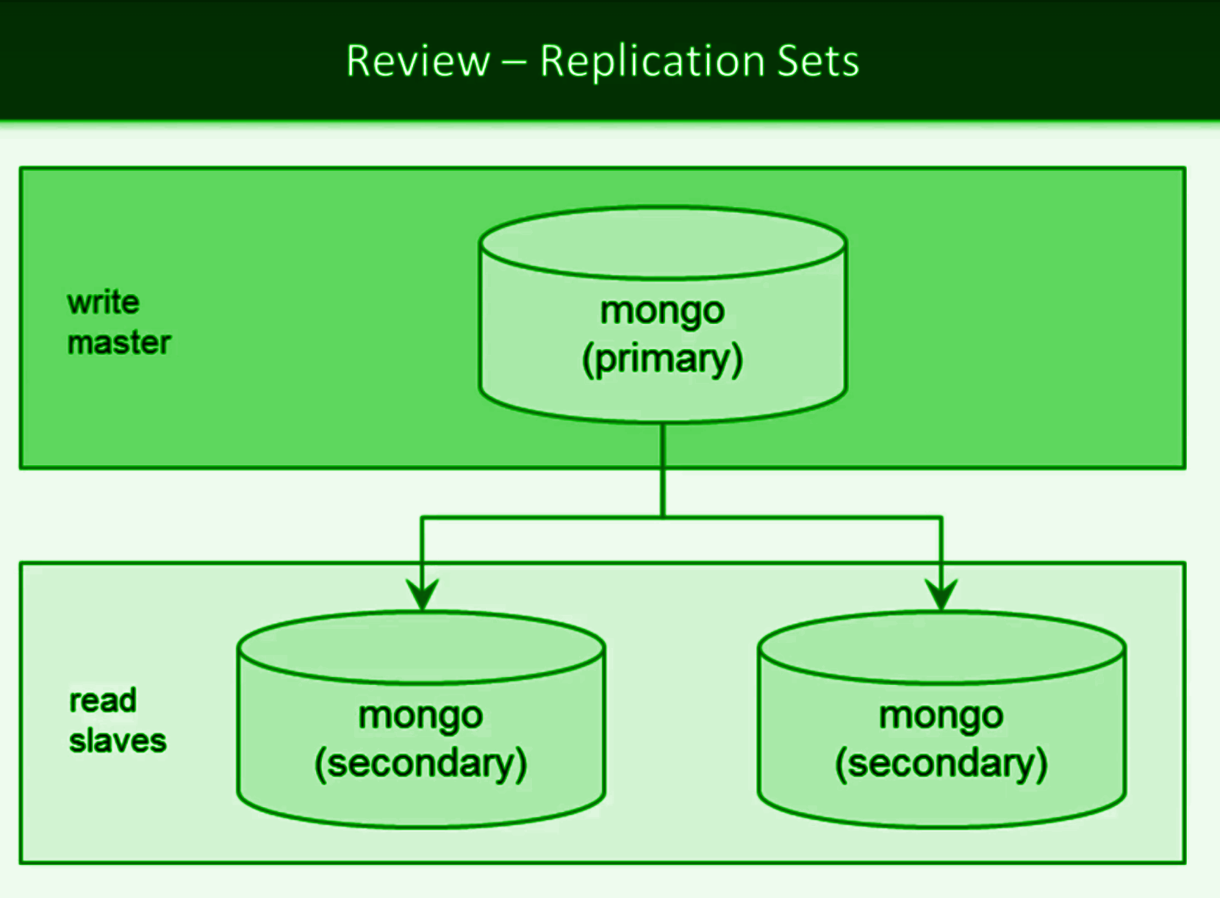

### **Difference between Replication and Sharding?**

* In Replication, all writes go to one node (PRIMARY/MASTER).
* In Sharding, writes are distributed across all the master nodes.
* In Replication, data is written to the primary and mongo propagates the data out to the secondary nodes.
* In Replication, more than 2 secondary nodes require an **ARBITER.**
* The **ARBITER** monitors the health of each node in a replica set through sending out heartbeats to each running node, it also helps decide which node would become primary in case of any failure, this can also be done by the secondary nodes themselves through a process called **ELECTION.**

### **Sharded Cluster:**

Sharded cluster is a series of replication clusters that are grouped (configured) as a shard.

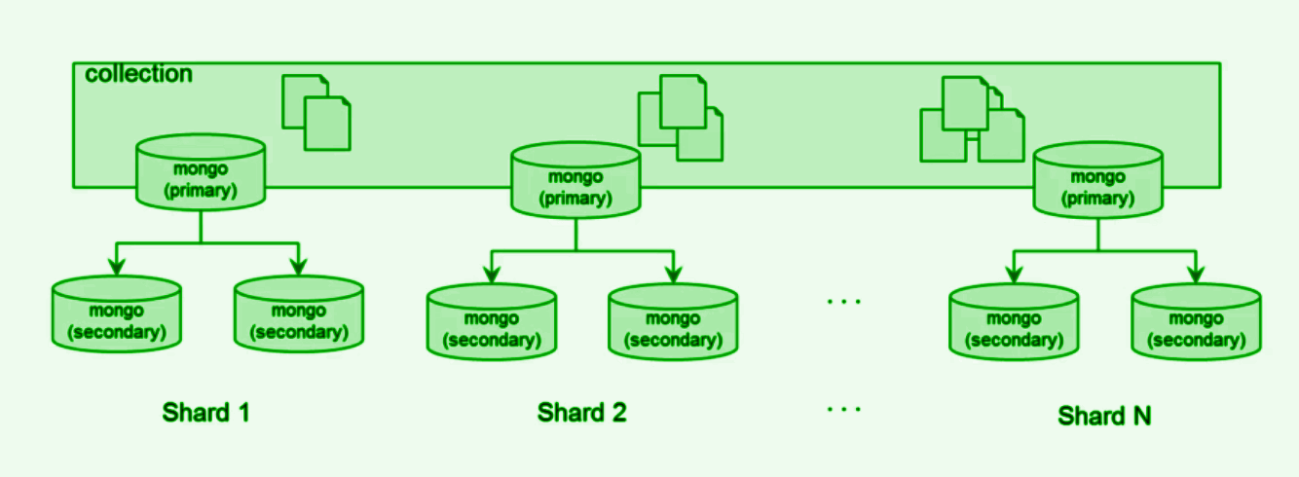

- Collections can be sharded or the entire database can be sharded.

- Sharding strategy decides which shard within the cluster hosts the data within the collection.

### **Shard Architecture:**

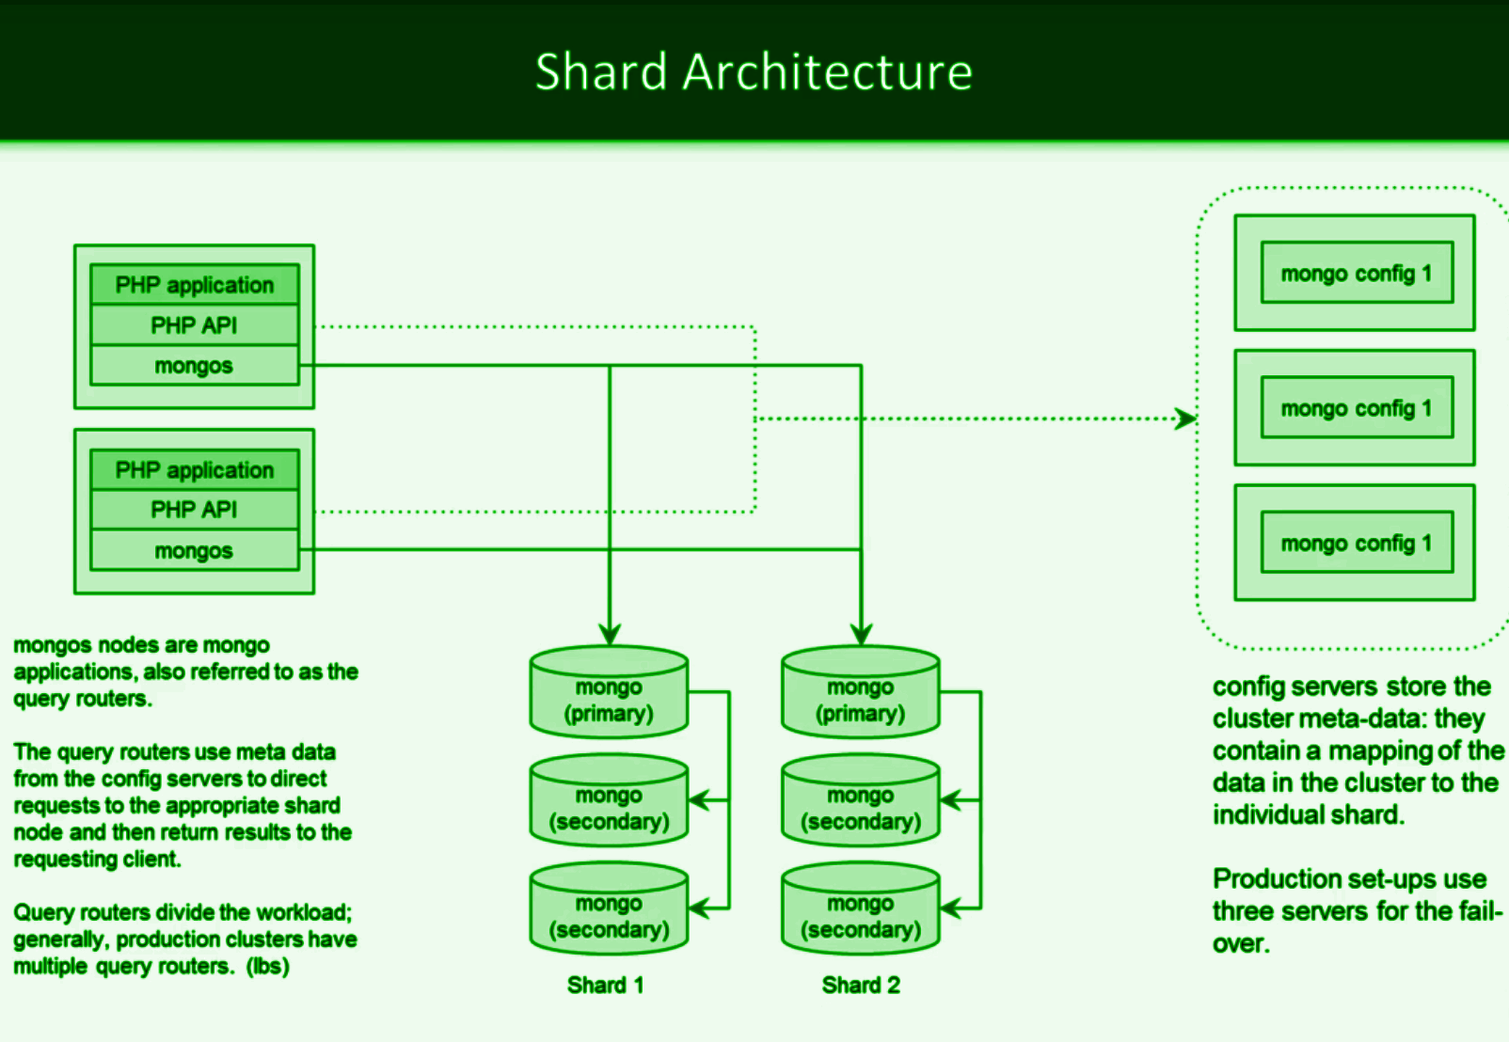

* Mongo config servers keep track of the mapping between the data records and their physical location within the shard on a cluster.
* In a production environment, we use at least 3 config servers as a recommended minimum by mongo for failover purposes ( similar to 3 nodes in a replication set).
* Query router allows us to divide the workload, process requests from the client in parallel. It also uses the meta data from the config servers to direct requests to the appropriate shard node and then return results to the requesting client.

### **Sharding Strategies:**

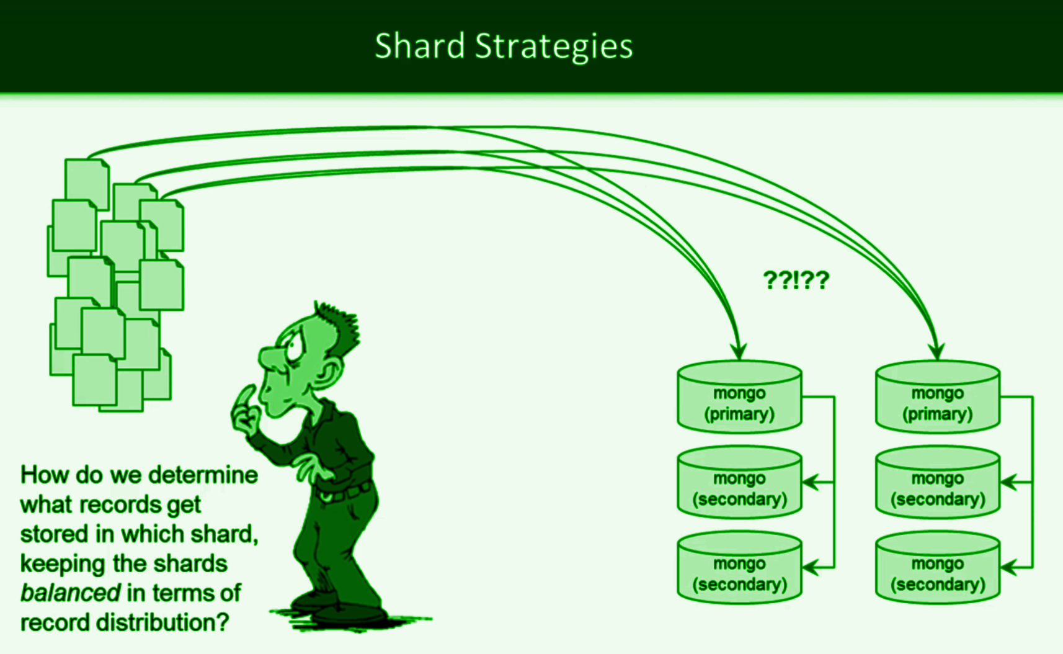

### **Two types of Shard strategies available in Mongo:**

1. Range based sharding strategy (Uneven distribution)
2. Hash based sharding strategy (Even distribution)

Analyze your data sets to determine the best strategy based on the selected shard key. Shard key selection is critical in determining the sharding strategy and its effectiveness. ?? **what are the available computing resources ( RAM, CPU, Disk)** ?? ?? **What types of queries will you be executing** ??

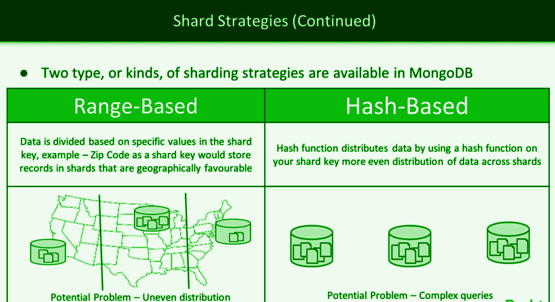

## **SHARDING TOPOLOGY:**

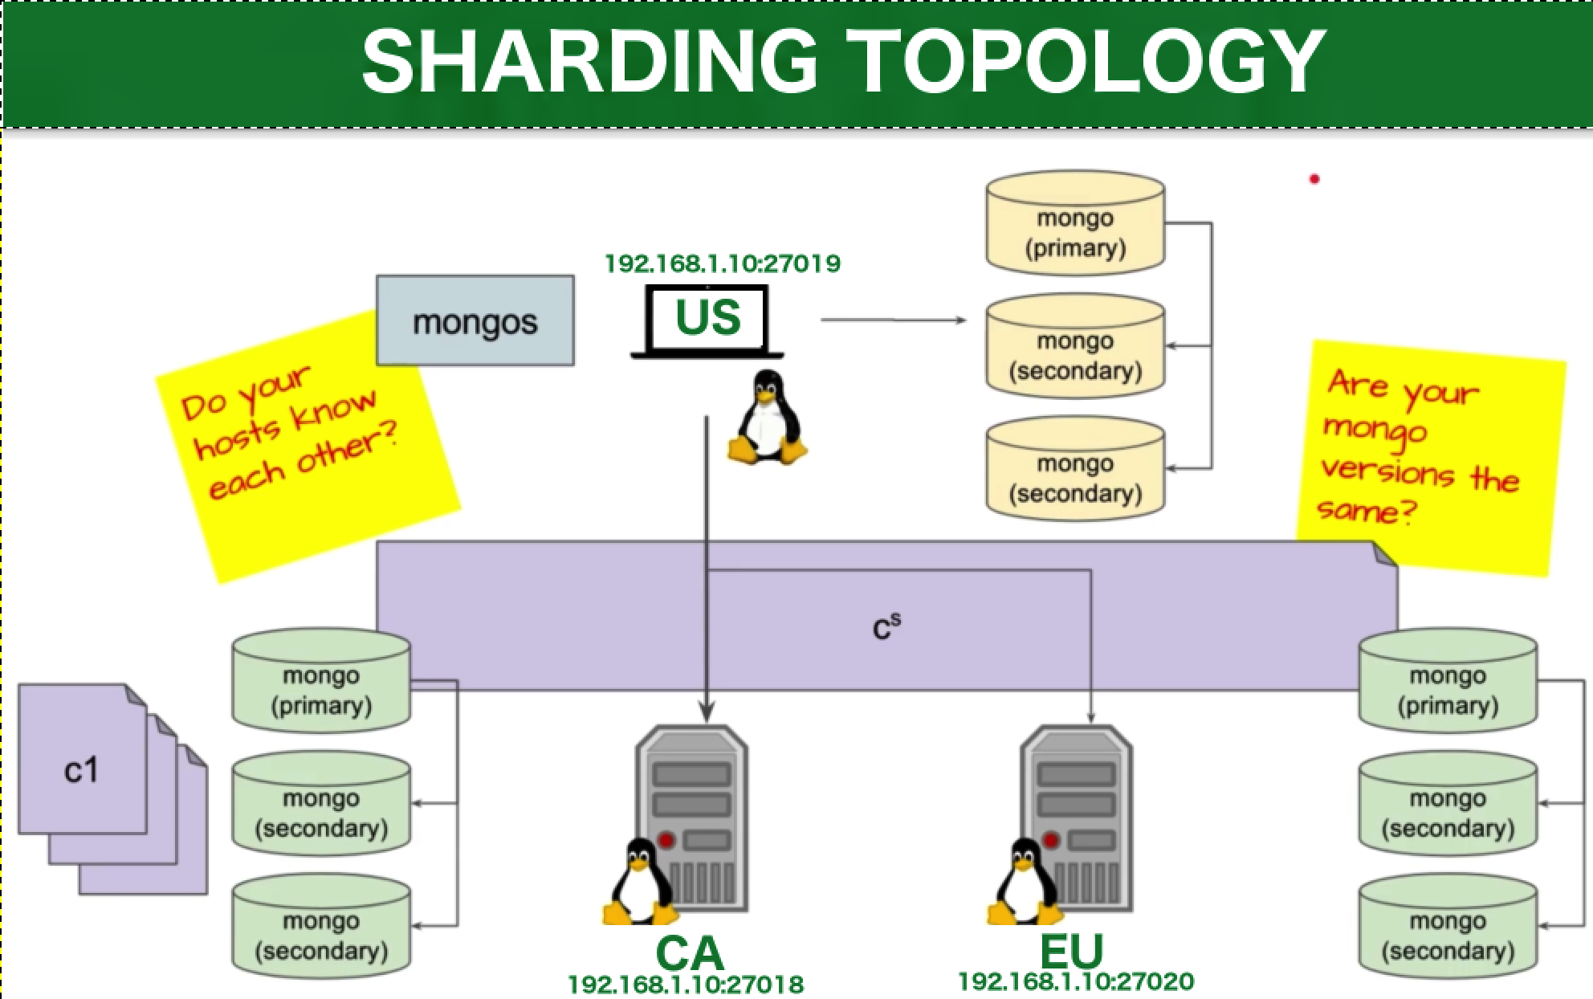

## **SHARDING CONFIGURATION:**

**Production Network:**

11 instances - **3, 7, 9 nodes, Host configuration** (define /etc/hosts for every node, add the other nodes to the /etc/hosts file so that all the nodes know each other) & **2 Query routers.**

### **Installing the configuration Replication Set:**